AUTHENTIC LINGUINE WITH BASIL PESTO  COOK TIME: 10 min  SOURCE:  #pasta #comfort-food #quick | 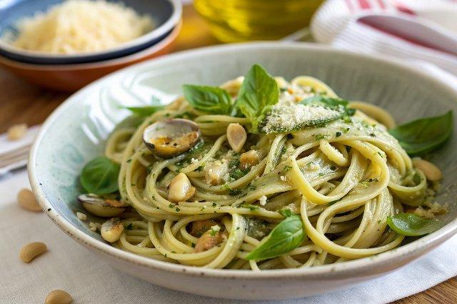

INGREDIENTS  - 50 g basil leaves  - 1/2 garlic clove (optional)  - 15-20 g pine nuts  - 85 ml extra virgin olive oil  - 30 g grated Grana Padano cheese plus extra to serve  - 30 g grated Pecorino plus extra to serve  - 400 g linguine  - 120 g diced potatoes  - 150 g trimmed French beans | PREP  COOK  1. Rinse the basil leaves well and pat dry gently with a clean tea towel, as you don’t want to tear the leaves or they will oxidise quickly.  2. Using a pestle and mortar, crush the garlic with a pinch of salt until well smashed, then add the pine nuts and repeat. Now add the basil and keep going with the pestle until partially broken down. Add the olive oil and the cheeses and grind everything together. The pesto will keep in a clean jar well sealed in the fridge for three-four days. Make sure you leave a little layer of oil on the top of the pesto to protect it from oxidisation. My mum also freezes her pesto for up to six months, although expect some discolouring when defrosted.  3. Drop the pasta into a pan of salted boiling water and add the potatoes and French beans to the pan, if using. The potato starch will help the pesto to cling to the pasta. Drain, reserving a little pasta water.  4. Toss the pasta in a clean bowl with the potatoes, beans and pesto. Make sure you do this off the heat as the pesto should never be returned to the stove. Mix well and add a ladleful of reserved pasta water, if needed, to loosen the sauce. Once the pasta is well coated and glossy, serve straightaway with a little more cheese scattered over.  PLATING

