DUTCH OVEN BREAD  COOK TIME: 45 min  SOURCE:  #homemade #comfort-food #baking | 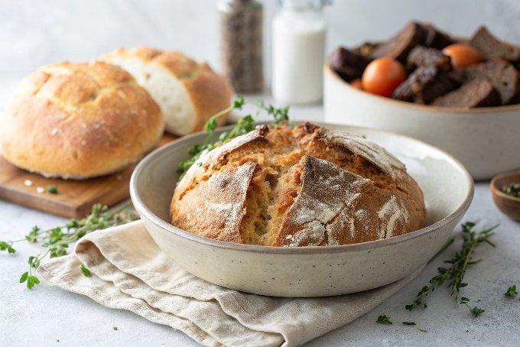

INGREDIENTS  - 3 cups (720ml) all purpose flour  - 1 1/2 tsp salt  - 1 packet instant yeast ( 2 1/4 tsp)  - 1 1/2 cups warm water (not hot or it will kill the yeast) | PREP  COOK  1. In a large bowl, stir together the flour, salt and instant yeast.  2. Add the warm water and stir together until a sticky dough forms. Don't worry about it looking like a round ball of dough; it will be quite messy and that is fine.  3. Cover the bowl with a clean tea towel and set in a warm place to rise for 2 hours. I preheat my oven to 200°F (95°C), then quickly turn it off, place the bowl inside the oven with the door cracked for about 15 minutes, then close the oven door and continue to let it rise for the whole 2 hours. If your house is warm, you can just use the counter.  4. About a half hour before the rise time is done, preheat the oven to 450 degrees F (if you used your oven to help the dough rise, remove the bowl before preheating) and place your dutch oven inside the oven, with the lid on, while the oven preheats. We want the dutch oven HOT when the dough goes in! Once the oven preheats, leave it in there for another 10-15 minutes, until your dough is ready to be transferred in.  5. Prepare the dough: Place a large square of parchment paper on a counter and sprinkle it with flour. Using a spatula, transfer the dough to the floured surface as one big blob.  6. Sprinkle a little flour on top of the dough, and use a spatula to gently fold the dough on top of itself (see photos above in post) about 4-6 times.  7. Gently shape it into a round loaf type shape in the center of the parchment paper (it doesn't have to be perfect at all), using lightly floured hands or the spatula. Be careful not to handle the dough too much or it will lose those wonderful air pockets. If desired, cut several shallow lines using a sharp, serrated knife.  8. CAREFULLY remove the HOT dutch oven and remove the lid using oven mitts. Using the parchment paper, place the dough inside the dutch oven and place the lid back on. You will cook it with the parchment paper, and it's okay if a little bit sticks out of the lid.  9. Place the dutch oven back in the oven and bake for 35 minutes. Remove the lid (with oven mitts!) and bake for about 10-15 minutes, until the crust is golden brown.  1  0. Remove the dutch oven from the oven, and transfer the bread to a cutting board to cool for about 30 minutes before slicing. Enjoy!  1  1. Keep the bread covered at room temperature for 2-3 days, or a little longer in the refrigerator. It also freezes well!  PLATING

