ACTUALLY GOOD QUINOA SALAD  COOK TIME: 50 min  SOURCE:  #healthy #quick #fresh | 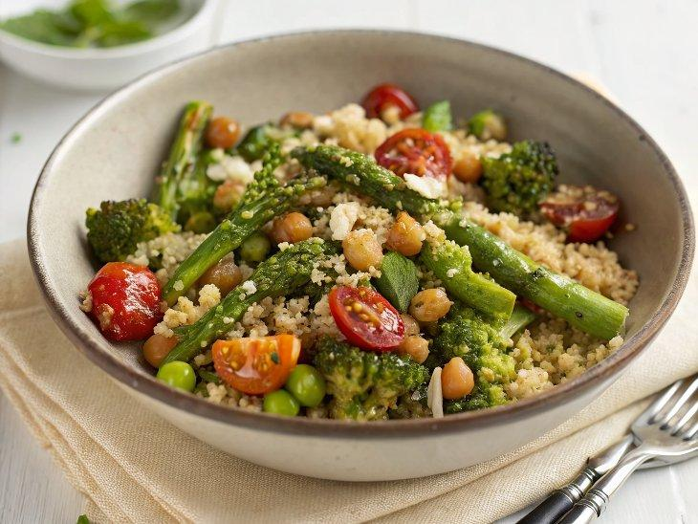

INGREDIENTS  - 1 cup (180 g) uncooked quinoa  - 4 tbsp extra virgin olive oil, (divided)  - Spring: asparagus, snap peas, fennel (early spring)  - Summer: sweet cherry/grape tomatoes, (halved)  - Fall: any winter squash  - Winter: fennel, broccoli or cauliflower or Brussels sprouts  - 1 (15-oz/425 g) can chickpeas, (drained and rinsed)  - 1 medium shallot, (finely diced (or 1/4 cup / 30 g finely diced red onion)  - 1 medium lemon, (zested + 2 tbsp juice (more juice for the end)  - 1 1/2 tbsp pomegranate molasses (or aged balsamic vinegar, see Note 2)  - 1 big handful (1 cup / 16 g) of flat-leaf parsley leaves (or basil or dill, depending on vegetable used), chopped)  - 2 garlic cloves, (crushed with a press or grated finely)  - 1 tsp kosher salt  - Freshly cracked black pepper  - 1/4 tsp red pepper flake (optional for a touch of heat)  - 1/2 cup (70 g) roasted almonds and/or pistachios, (chopped (optional; see Note 3 for nut-free)  - 1/2 cup (60 g) vegan feta, (crumbled)  - Something pickled, like pickled onions  - A big handful of sweet cherry tomatoes, (halved or quartered) | PREP  COOK  1. Bring 1 ¼ cups of water (300 mL) to a boil. Meanwhile, rinse the quinoa in a fine mesh sieve under cool running water.  2. Once the water is boiling, add the rinsed quinoa and a pinch of salt. Reduce the heat to low and cook, covered, until the liquid has evaporated and quinoa is tender, about 12 minutes. Open the pot and fluff with a fork. Transfer quinoa to a sheet pan and spread out in an even layer. Allow to cool somewhat.  3. Preheat the oven to 425ºF/218ºC. Arrange a rack in the bottommost and in the top third of the oven.  4. Meanwhile, slice your vegetables (see Note 1).  5. Spread the vegetables out on a sheet pan in a single layer as much as possible. Drizzle with about 1 tablespoon of olive oil. Season with salt and pepper to taste.a. If the quinoa is not done yet, start on the chickpeas (step 8).  6. To the cooked quinoa on the other sheet pan, toss with 1 ½ tablespoons oil and ½ teaspoon kosher salt. Mix with your hands to coat. Spread out with as little overlap as possible.  7. Roast the quinoa and veggies: Transfer the vegetables to the bottom rack and quinoa to the upper rack. After 15 minutes, toss the quinoa (no need to toss veggies). Continue baking, checking the quinoa every 5 minutes until the quinoa is crispy and golden brown in spots and the vegetables are tender and browned in spots (they both should take about 25 minutes).  8. Meanwhile, in a large bowl, combine the chickpeas, shallot, 1 ½ tablespoons olive oil, lemon zest and 2 tablespoons juice, pomegranate molasses, herbs, garlic, salt, pepper to taste, and red pepper flakes if using. Toss well and set aside to marinate for 10 minutes or longer. Toss a few times.  9. Add the roasted vegetables, toasted quinoa, and toasted nuts to the marinated chickpeas. Gently toss. Crumble in the feta if using and sprinkle with a pinch of salt and pepper to taste. Before serving, squeeze a little lemon juice on top if you have leftover lemon from the marinated chickpeas.  PLATING

