MALL CHICKEN TERIYAKI  COOK TIME: 5 min  SOURCE:  #quick #comfort-food #stir-fry | 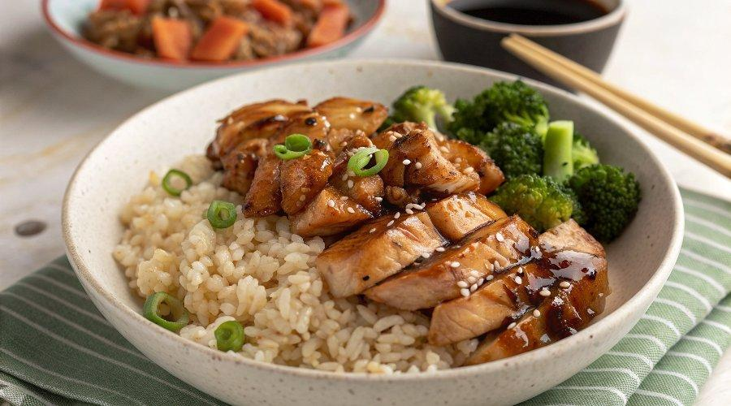

INGREDIENTS  - 2 lb boneless skinless chicken thighs (900 g, cut into small chunks)  - 3 1/2 tbsp mirin  - 3 1/2 tbsp soy sauce  - 1 1/2 tsp dark soy sauce  - 2 tbsp brown sugar  - 1 tsp ginger (grated)  - 1 1/2 tsp sesame oil  - 1 tbsp cornstarch  - 2 tbsp oil | PREP  COOK  1. Add the chicken to a bowl, along with the mirin, soy sauce, dark soy sauce, brown sugar, ginger, sesame oil, and cornstarch. Mix together until all the ingredients are well combined. Allow to marinate for 2 hours.  2. Heat the oil in a wok or large skillet over medium high heat. Transfer the chicken to the pan in one layer (reserving the marinade), and allow it to sear on one side for 1 minute. Then start stir-frying for another minute.  3. Add the reserved marinade to the pan, reduce the heat to medium, and simmer to reduce the sauce until it thickens and coats the chicken. Serve over rice!  PLATING

