VEGAN SUNFLOWER SEED CHEESE  COOK TIME: 15 min  SOURCE:  #dairy-free #healthy #spread | 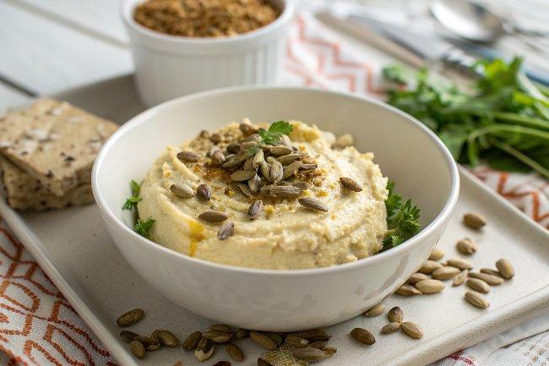

INGREDIENTS  - 2 cups (480ml) raw sunflower seeds, (softened (see step 1))  - 1/4 cup nutritional yeast  - 1/4 cup lemon juice  - 1/4 cup refined coconut oil  - 4 tsp white miso paste  - 1 tsp garlic powder  - 1 tsp smoked paprika  - 1/2 tsp salt ((or to taste))  - 1/2 tsp ground turmeric | PREP  COOK  1. To soften the sunflower seeds:  2. To make vegan sunflower seed cheese:  PLATING

