ROASTED GARLIC MASHED POTATOES  COOK TIME: 15 min  SOURCE:  #comfort-food #mashed-potatoes #sidedish | 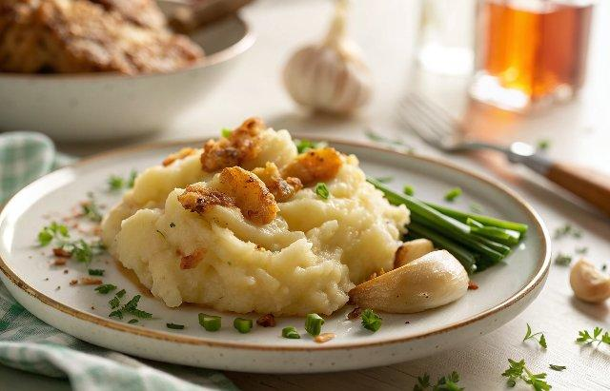

INGREDIENTS  - 1 head roasted garlic, (use this recipe)  - 2 lb russet potatoes, (peeled and cubed)  - 2 1/2 tsp kosher salt, (divided)  - 1/2 tsp black pepper  - 1 1/2 cups buttermilk  - minced chives, (for garnish) | PREP  COOK  1. Fill a large pot with cold water: Fill a large pot with cold water.  2. Add the potatoes: Add the peeled, cubed potatoes to the pot with water. Make sure they are covered by at least 2-inch (5cm) of water and turn the burner to medium-high. Once the water begins to boil, add 2 teaspoons salt, and reduce to a simmer. Let the potatoes cook until they are soft and fork-tender, about 15 minutes. Cook time can vary depending on how small you cube the potatoes.  3. Drain and return to the pot: Once the potatoes are cooked. Drain them in a colander, then add them back to the pot and return the pot to the burner. Turn the heat to low. Add the milk, the remaining 1/2 teaspoon of salt, pepper, and squeeze the roasted garlic cloves into the pot. Mash it with a potato masher until the potatoes are smooth and fluffy and the garlic has been equally distributed. Taste and add additional salt and pepper if needed.  4. Serve: Transfer the roasted garlic mashed potatoes to a serving bowl, top with minced chives if using. Enjoy!  PLATING

