BAKED ZITI  COOK TIME: 50 min  SOURCE:  #comfort-food #pasta #baked | 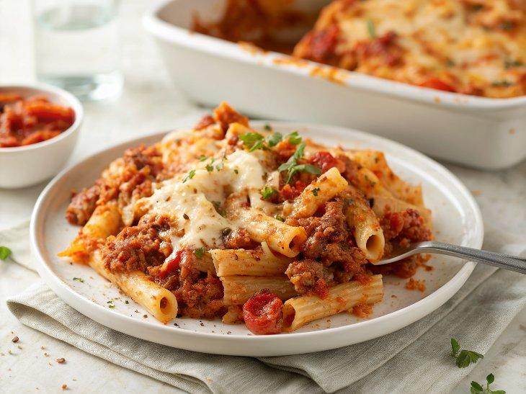

INGREDIENTS  - 1 lb ziti noodles  - 1 1/2 lbs ground spicy or sweet Italian sausage (or removed from casings)  - 4 cloves garlic, (minced)  - 1 (28-oz) can crushed tomatoes  - 1 tsp salt  - 1 1/2 tsp sugar  - 1/4 tsp crushed red pepper flakes  - 1 cup (240ml) heavy cream  - 1/3 cup plus 3 tbsp grated pecorino Romano (or Parmigiano Reggiano cheese), divided)  - 1/3 cup chopped fresh basil, (plus more for serving)  - 8 oz whole milk mozzarella cheese, (shredded (about 2 cups) | PREP  COOK  1. Bring a large pot of salted water to a boil. Add the ziti noodles and cook according to the package directions for very al dente, about 7 minutes. (It will continue to cook in the oven, so you want to undercook it just a bit.) Drain and add the pasta back to the pot. Set aside.  2. Preheat the oven to 425°F (220°C) and set the oven rack in the middle position.  3. Heat a large sauté pan (preferably nonstick) over medium-high heat. Crumble the sausage into the pan and cook, breaking apart with a wooden spoon, until lightly browned and just cooked through, 5 to 6 minutes. Use a slotted spoon to transfer the cooked sausage to a plate. Drain all but 1 tablespoon of the fat from the pan and set over low heat (if you don't have enough fat in the pan, add a tablespoon of olive oil). Add the 4 cloves of minced garlic and cook, stirring constantly with a wooden spoon, until soft but not browned, about 1 minute. Add the can of crushed tomatoes, 1 teaspoon salt, 1½ teaspoons sugar, and ¼ teaspoon red pepper flakes and simmer, uncovered, for 10 minutes.  4. Add the cream, ⅓ cup (33 g) of the pecorino Romano, cooked sausage, and basil to the pan; stir until evenly combined. Carefully pour the contents of the sauté pan into the large pot with the pasta and gently stir to combine. Spoon half of the mixture into a 9 x 13-inch (23 x 33-cm) baking dish. Sprinkle with half of the shredded mozzarella (1 cup/113 g) and half the remaining pecorino Romano (1½ tablespoons). Spoon the remaining pasta mixture on top and sprinkle with the remaining mozzarella (1 cup/113 g) and pecorino Romano (1½ tablespoons). Transfer to the oven and bake, uncovered, until the cheese has melted and browned, 15 to 20 minutes. Sprinkle with more basil and serve.  PLATING

