EASY LEMON BLUEBERRY CAKE  COOK TIME: 1h  SOURCE:  #quick #comfort-food #baking | 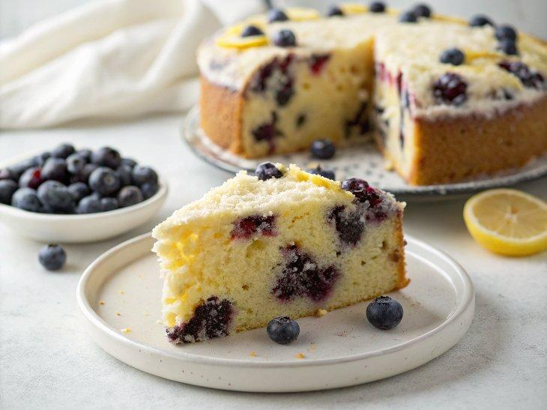

INGREDIENTS  - 8 tbsp unsalted butter, melted and cooled (115 g)  - 1 1/3 cups all-purpose flour (170 g)  - 1 1/4 tsp baking powder  - 1/4 tsp sea salt  - 1 cup (240ml) plus 3 tbsp granulated sugar (240 g)  - 1/2 tsp ground cinnamon  - 2 tsp lemon zest  - 1 tsp vanilla extract  - 1/4 tsp almond extract  - 3 large eggs at room temperature  - 1/3 cup heavy cream (80 ml)  - 2 cups (480ml) fresh blueberries, about 1 pint blueberries (280 g)  - 2 cups (480ml) homemade whipped cream, optional | PREP  COOK  1. Prep: Center a rack in the oven and heat to 350°F (177°C). Butter and flour an 8- or 9-inch (23cm) square pan.  2. Mix dry ingredients: Whisk the flour, baking powder, and salt in a medium bowl.  3. Make flavored sugar: In a separate bowl, rub the sugar, cinnamon, lemon zest, vanilla, and almond extract together until the sugar is moist and fragrant. (Use your fingers to rub the aromatics into the sugar.)  4. Mix wet ingredients: Whisk the eggs into the flavored sugar until blended, then whisk in the cream.  5. Make batter: Switch to a large rubber spatula. Add the dry ingredients in three additions, stirring gently until just incorporated and the batter is smooth. Fold in the melted butter in two additions. The batter will be thick.  6. Layer the batter: Spread about one-third of the plain batter into the bottom of the prepared pan (without any berries).  7. Then, fold all but a handful of the blueberries into the remaining batter. Spoon this blueberry batter over the first layer and smooth the top. Scatter the reserved berries over the surface.  8. Bake: Bake for 50 to 60 minutes, or until a knife inserted into the center comes out clean. Transfer the pan to a wire rack and cool for 5 minutes. Remove the cake from the pan, place it right-side up on the rack, and let it cool completely. Serve with whipped cream.  PLATING

