MUSHROOM & CHICKPEA COCONUT CURRY  COOK TIME: 15 min  SOURCE:  #comfort-food #curry #quick | 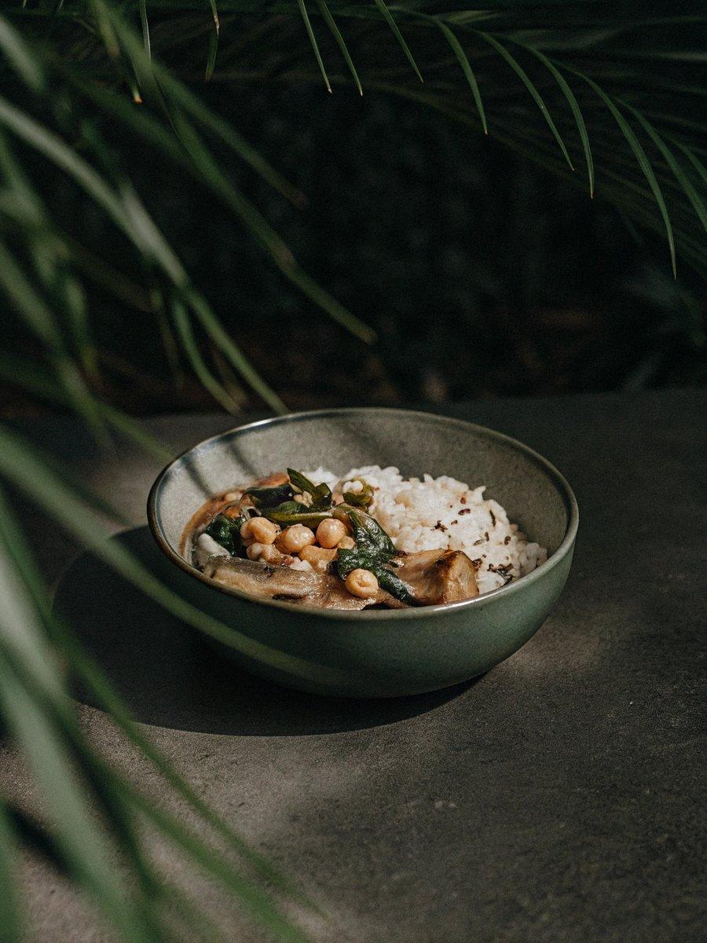

INGREDIENTS  - 1 cup (240ml) red rice  - vegetable oil  - 1 medium onion  - 3 garlic clove  - 1 Tbsp grated fresh ginger  - 2 cup (480ml) cooked chickpeas  - 6.173 oz button mushrooms  - 1 Tbsp curry powder  - 1/2 tsp sweet paprika powder  - 1 2/3 cup canned full-fat coconut milk  - 1 bell pepper  - 1 pinch salt  - 1 pinch ground black pepper  - 4 cup (960ml) fresh spinach  - 1 1/4 cup cherry tomatoes  - 1/2 lemon | PREP  COOK  1. Cook the rice according to the package instructions.  2. Meanwhile, heat the oil in a large pot over high heat. Cook the onion, garlic, and ginger for 3 minutes. Add splashes of water as needed to deglaze the pot.  3. Add the chickpeas and mushrooms to the pot and cook for 5 minutes.  4. Add the curry and paprika powder and sauté for one minute longer.  5. Add the coconut milk, bell pepper, salt, and pepper and cook for another 5 minutes.  6. Add the spinach and tomatoes at the end, and stir. When the spinach has wilted, remove from heat.  7. Serve the curry with the rice, squeeze over some lemon, and enjoy!  PLATING

