MEDITERRANEAN VEGAN CABBAGE SOUP (THREE WAYS)  COOK TIME: 35 min  SOURCE:  #comfort-food #healthy #quick | 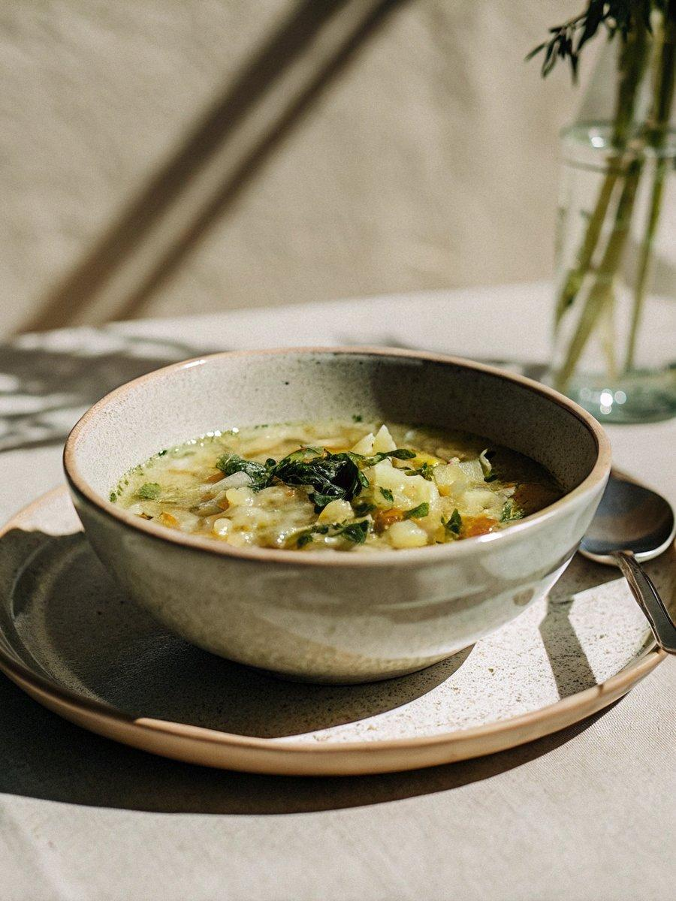

INGREDIENTS  - Extra virgin olive oil (I used Early Harvest Greek EVOO)  - 2 medium-sized onions, sliced into half moons (I used red and yellow onions)  - 2 garlic cloves, minced  - 2 large carrots, peeled and sliced into rounds  - 2 russet potatoes, scrubbed clean and sliced into 1/4-inch (10cm)-thick rounds  - 1 1/2 lb green cabbage (about 1/2 head of cabbage), cored and chopped  - Kosher salt and pepper  - 1 tbsp organic ground cumin  - 1 tsp sweet Spanish paprika  - 1/2 tsp ground coriander  - 1/4 tsp ground turmeric  - Bay leaf  - 1 cup (240ml) tomato sauce  - 6 to 7 cups (1680ml) low-sodium vegetable broth  - Zest plus juice of 1 lemon  - 1/2 cup fresh dill  - Pinch crushed red pepper (optional) | PREP  COOK  1. Stove-Top Cabbage Soup  2. In a large Dutch Oven or heavy pot, heat 2 tbsp extra virgin olive oil until shimmering but not smoking.  3. Add onions, garlic, carrots, potatoes, and chopped cabbage. Saute the vegetables for a bit until somewhat tender. Season with salt and pepper, then add the rest of the spices and bay leaf. Cook for a few more minutes, tossing regularly.  4. Stir in tomato sauce and broth. Raise the heat and bring the soup to a boil for 5 minutes, then turn heat to low and cover the pot only part-way. Cook for 30 to 40 minutes or until vegetables are tender.  5. Finally, stir in lemon zest, lemon juice and fresh dill (or your choice of fresh herb.) Transfer to serving bowls.  6. Crock Pot Cabbage Soup  7. Place carrots, potatoes, cabbage, onions and garlic in the bottom of a 6-quart crock pot like this one.  8. Season with kosher salt and pepper. Add spices, bay leaf, tomato sauce, and broth. Stir to combine.  9. Cover the crock pot (or slow cooker) and cook on LOW for 7 to 8 hours or on HIGH for 4 hours. Occasionally stir to mix.  1  0. When the soup is ready, unplug the crock pot. Stir in lemon zest, lemon juice, and fresh dill.  1  1. Transfer soup to serving bowls  1  2. Instant Pot Cabbage Soup  1  3. Add all the ingredients except the lemon juice, lemon zest, and fresh dill to the instant pot.  1  4. Lock the lid and lock the lid and set on high for a total time of 15 minutes, then let the pot naturally release (another 15-20 minutes.) When done, remove the lid and stir in the lemon zest, lemon juice and fresh dill. Transfer to serving bowls and enjoy!  1  5. Note: If you like, you can start by sauteing the vegetables in the instant pot first with some extra virgin olive before cooking.  PLATING

