CREAMY AVOCADO DIP  COOK TIME: 5 min  SOURCE:  #quick #healthy #dip | 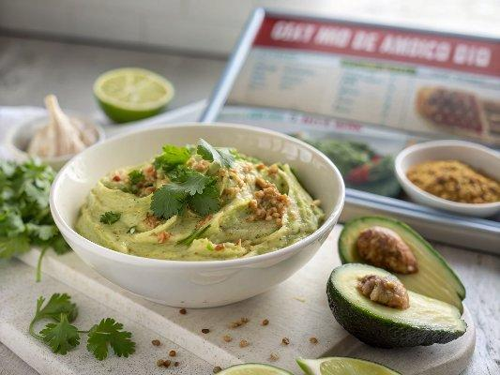

INGREDIENTS  - 2 large avocados, halved and pitted  - 1/2 cup lightly packed fresh cilantro (some stems are okay)  - 1/3 cup lime juice (from about 2 1/2 limes)  - 1 small jalapeño, seeds and ribs removed, roughly chopped  - 2 tbsp water, more as needed to thin  - 1/2 tsp fine sea salt | PREP  COOK  1. Using a spoon, scoop the flesh of the avocados into a food processor or blender. Add the cilantro, lime juice, jalapeño, water, and salt.  2. Process, stopping to scrape down the sides as necessary, until the sauce is smooth and creamy. (If the mixture refuses to blend, add additional water in 1-tablespoon increments, as necessary.)  3. If you would like a thinner, more drizzly sauce, add water in 1-tablespoon increments until it reaches your desired consistency. Taste, and add more salt if it’s not quite flavorful enough.  4. Transfer the avocado sauce to a small serving bowl. This sauce keeps well in the refrigerator, covered, for about 4 days.  PLATING

