JAPANESE GARLIC FRIED RICE  COOK TIME: 10 min  SOURCE:  #quick #comfort-food #fried-rice | 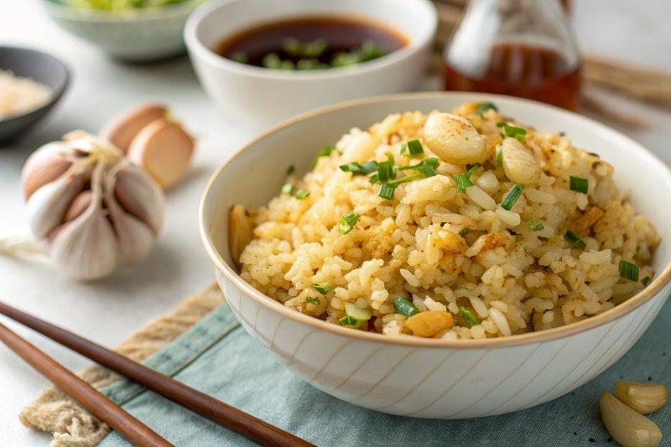

INGREDIENTS  - 4 cups (960ml) cooked Japanese short-grain rice (cooled or day old; frozen cooked rice works well)  - 2 cloves garlic (divided)  - 2 Tbsp extra virgin olive oil  - 1 Tbsp unsalted butter  - 1 tsp soy sauce  - 1/4 tsp Diamond Crystal kosher salt (or more, to taste)  - freshly ground black pepper  - 3 stalks parsley  - 6 pieces shrimp (medium size)  - 1/2 Tbsp extra virgin olive oil  - 1 Tbsp sake  - Diamond Crystal kosher salt  - freshly ground black pepper | PREP  COOK  1. Gather all the ingredients. For the steamed rice, please note that 1½ cups (300 g, 2 rice cooker cups) of uncooked Japanese short-grain rice yield 4⅓ cups (660 g) of cooked rice. See how to cook it with a rice cooker, pot over the stove, Instant Pot, or donabe.  2. To Prepare the Ingredients  3. For your 4 cups (960ml) cooked Japanese short-grain rice, make sure it‘s at room temperature or slightly warmer. If you‘re using frozen cooked rice, defrost and warm it. Tip: If your cooked rice is still hot, transfer it to a large bowl or baking sheet (for more surface area). Spread it out and set aside for 60 minutes, uncovered, to remove the moisture.  4. Cut half of the 2 cloves garlic into thin rounds widthwise (so you see a hole in the center). Mince the other half.  5. Remove the leaves from the stems of 3 stalks parsley and mince the leaves.  6. To Cook the Garlic Fried Rice  7. Add 2 Tbsp extra virgin olive oil and the thinly sliced garlic pieces to a large frying pan over medium-high heat (or medium heat on a professional stove). Slowly fry the garlic slices until golden brown. If you add them to hot oil, they will cook too fast and you may end up with burnt garlic slices. Transfer to a dish lined with paper towel. Keep the garlic-infused oil in the pan.  8. Add the minced garlic to the same pan and stir-fry until golden brown and fragrant.  9. Add 1 Tbsp unsalted butter and swirl around to coat the pan. Then, add the steamed rice. Tip: If you use cold rice, it would take too long to warm up and the garlic would get too dark and may burn.  1  0. Break up the chunks of rice with a wooden spatula to separate. Japanese short-grain rice is stickier than other types of rice, so it’s normal to stick together but it should not be in huge chunks. Once the rice is well coated in the garlic oil, add 1 tsp soy sauce and toss to coat the rice.  1  1. Season with ¼ tsp Diamond Crystal kosher salt and freshly ground black pepper. Taste the rice and make sure it is seasoned to your liking.  1  2. Lastly, add the chopped parsley and mix it all together.  1  3. To Serve  1  4. Put the garlic fried rice in a rice bowl, pressing gently to make sure there is no space in the bowl, and invert the rice on an individual serving plate. Top with the fried garlic chips.  1  5. To Make the Grilled Shrimp Skewers (optional)  1  6. If you‘d like to serve the garlic fried rice with grilled shrimp skewers, then shell 6 pieces shrimp and devein the shrimp. You can keep or remove the tail. Add 1 Tbsp sake and coat the shrimp well.  1  7. Thread 3 shrimp on each damp skewer (previously soaked in water) without leaving spaces. Sprinkle with Diamond Crystal kosher salt and freshly ground black pepper.  1  8. Lay the skewers flat on a cast iron pan (or regular frying pan) greased with ½ Tbsp extra virgin olive oil. Cook the shrimp with the lid on about 2 minutes per side or just until cooked through and no longer transparent. Remove the shrimp from the pan and serve with the garlic fried rice.  1  9. To Store  2  0. You can keep the leftovers in an airtight container and store in the refrigerator for 3–4 days and in the freezer for a month.  PLATING

