SPINACH & CHEESE STRATA  COOK TIME: 1h 15m  SOURCE:  #comfort-food #casserole #make-ahead | 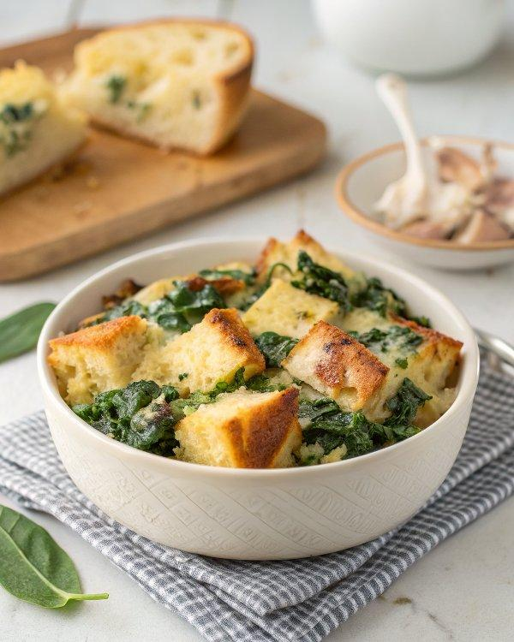

INGREDIENTS  - 1 lb bag chopped frozen spinach, thawed and squeezed as dry as possible  - 3 tbsp unsalted butter  - 1 large yellow onion, chopped (about 2 cups)  - 3 garlic cloves, minced  - 12 oz ( 3/4 lb) Italian sandwich bread, cut into 1-inch (3cm) cubes (about 11 slices or 8 cups)  - 6 oz (1 1/2 cups) coarsely grated Gruyère  - 2 oz ( 2/3 cup) finely grated Parmigiano-Reggiano  - 9 large eggs  - 2 3/4 cups half-and-half  - 2 tbsp Dijon mustard  - 1 3/4 tsp salt  - 3/4 tsp black pepper  - 1/4 tsp ground nutmeg | PREP  COOK  1. Melt the butter in a large skillet over medium heat. Add the onion and cook, stirring frequently, until soft and translucent, 4 to 5 minutes. Add the garlic and drained spinach and cook 2 minutes more. Set aside.  2. Butter a 3-quart or 9x13-inch (23x33cm) baking dish. Spread one third of the bread cubes in the dish and top evenly with one third of spinach mixture. (Try to break it up as much as possible so there are no huge clumps of spinach.) Sprinkle with one third of each cheese. Repeat layering twice, ending with cheeses.  3. In a large bowl, whisk the eggs. Add the half-and-half, mustard, salt, pepper, and nutmeg and whisk until well combined. Pour the custard mixture evenly over the strata. Cover the strata with plastic wrap and chill for at least 1 hour or overnight.  4. Preheat oven to 325°F (160°C). Bake the strata, uncovered, until puffed, set and golden brown all over top, 70-80 minutes. Let stand 10 to 15 minutes before serving. It will settle a bit as it cools.  5. Note: The cook time is based on the strata going immediately from the fridge to the oven. If it sits out at room temperature before baking, the cook time will be about 10 minutes less.  6. Freezing Instructions: To freeze, assemble the strata but don’t bake it. Wrap it tightly in plastic wrap, then aluminum foil, and freeze for up to 2 months. When ready to bake, thaw the strata overnight in the refrigerator. Alternatively, you can freeze leftover baked strata in individual portions, wrapping them tightly before freezing. Reheat from frozen in a 350°F (175°C) oven until warmed through.  PLATING

