PERFECT CINNAMON ROLLS  COOK TIME: 30 min  SOURCE:  #comfort-food #baking #sweet | 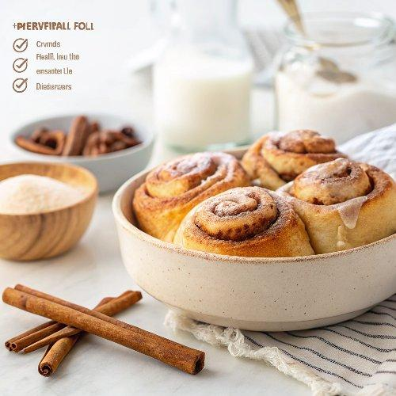

INGREDIENTS  - 1/4 cup (60 ml) whole milk  - 3 tbsp plus 1 tsp (38 g) granulated sugar, divided  - 2 1/4 tsp (7 g) instant yeast, one 1/4-oz packet  - 2 cups (480ml) plus 2 tbsp (268 g) all-purpose flour  - 1/2 tsp fine sea salt  - 1/2 tsp ground cinnamon  - 6 tbsp (85 g) cold unsalted butter, plus more for the dish  - 2 large eggs, beaten  - 1/4 cup (60 ml) heavy cream for pouring over rolls before baking, optional  - 6 tbsp (85 g) unsalted butter  - 1/4 cup packed (50 g) dark brown sugar  - 2 tbsp (25 g) granulated sugar  - 1 tbsp ground cinnamon  - 1/2 tsp ground cardamom, optional  - Pinch freshly grated nutmeg, optional  - 2 tbsp (30 g) cream cheese, softened  - 2 tbsp (30 ml) heavy cream  - 1/4 tsp vanilla extract  - 4 tbsp (30 g) powdered sugar  - Pinch fine sea salt | PREP  COOK  1. Make the Dough  2. To activate the yeast, warm the milk to 110°F (45°C). If you don’t have a thermometer, test the temperature by dipping your finger into the milk. It should feel warm, not hot.  3. Combine the warm milk, 1 teaspoon of sugar, and yeast in a small bowl. Whisk gently to incorporate, then set the mixture aside for 10 to 15 minutes. By the end of this time, the mixture should have transformed into a bubbly mass (refer to our video for a visual reference). If it hasn’t, your yeast may be expired and should be replaced.  4. While the yeast activates, prepare the dry ingredients. In the bowl of a food processor, combine the flour, 3 tablespoons of sugar, salt, and 1/2 teaspoon of cinnamon. Pulse the mixture 2 to 3 times until well blended.  5. Next, cut the butter into 6 equal pieces and scatter them over the flour mixture. Pulse the food processor until the butter is evenly distributed and the mixture resembles fine crumbs.  6. Add the yeast mixture to the food processor and pulse twice to incorporate. Add the eggs and continue processing until the dough comes together in a rough, sticky ball that climbs the sides of the bowl.  7. Transfer the dough to a well-floured surface, using a spatula to scrape any remaining dough from the food processor bowl. Knead the dough for one to two minutes or until smooth, adding flour as needed to prevent sticking.  8. Shape the dough into a ball and place it in a large bowl that you’ve lightly coated with oil. Cover the bowl with a clean dish towel and let the dough rise in a warm spot until it doubles in size. This usually takes 60 to 90 minutes.  9. Assemble Cinnamon Rolls  1  0. To make the cinnamon filling, warm 6 tablespoons of butter until it’s almost melted, then stir in the sugars, cinnamon, cardamom, and nutmeg. Set this mixture aside at room temperature to slightly firm up while you prepare the dough.  1  1. Lightly butter an 8-inch (20cm) round cake pan or small baking dish (mine is 9×6 inches).  1  2. Once the dough has risen, transfer it to a lightly floured surface and roll it into a 13×13-inch (33cm) square. Brush off any excess flour and spread the cinnamon sugar filling evenly across the dough, making sure to reach all the edges.  1  3. Starting at the edge closest to you, tightly roll the dough into a spiral. If the ends are uneven, trim about 1/2-inch (5cm) from each side for a cleaner look. Slice the roll into 6 equal pieces, each about 2-inch (5cm) wide. If the dough is too soft to cut easily, place the roll on a sheet of parchment paper on a baking sheet and chill it in the refrigerator for 20 minutes, or freeze it for 5 minutes before cutting.  1  4. Arrange the rolls in the buttered pan (for the round pan, place five rolls around the edge and one in the middle).  1  5. Cover them with a clean dish towel, and let them rise in a warm place for at least 30 minutes (45 minutes is better).  1  6. After 15 to 20 minutes of rising, preheat your oven to 350°F (176°C).  1  7. Bake Cinnamon Rolls  1  8. Remove the dish towel from the pan and, if desired, spoon the heavy cream over the rolls. This step is optional but adds extra richness and moisture.  1  9. Bake the rolls in the preheated 350°F (176°C) oven for 20 to 30 minutes, or until they turn golden brown on top and are cooked through in the center. Once baked, transfer the rolls to a cooling rack and let them cool for 30 minutes before glazing.  2  0. While the rolls cool, prepare the cream cheese glaze. Place the cream cheese in a medium microwave-safe bowl and microwave it for 10 to 20 seconds or until softened.  2  1. Add the heavy cream and vanilla extract, then whisk until smooth. Gradually whisk in the powdered sugar and a pinch of salt until you achieve your desired consistency. Set the glaze aside.  2  2. Once the rolls have cooled slightly, drizzle the cream cheese glaze generously over them. Serve and enjoy!  PLATING

