COLLARD GREENS  COOK TIME: 1h 15m  SOURCE:  #comfort-food #southern #vegetable | 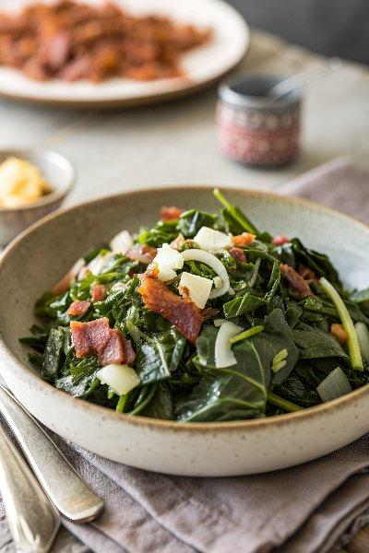

INGREDIENTS  - 2 bunches fresh collard greens (2 1/2 lb/1125 g)  - 1 tbsp olive oil  - 6 slices bacon (chopped)  - 1 large onion (finely chopped)  - 3 garlic cloves (minced)  - 2 tbsp sugar  - 1 tsp salt  - 1 tsp ground black pepper  - 1 pinch red pepper flakes  - 2 tbsp apple cider vinegar | PREP  COOK  1. To strip the collard leaves from the stem, start by holding the stem at the base of the leaves with one hand, and pull the stem away with the other hand ripping the leaves from the stem. Or, you can fold the leaves in half so that the stem is on one side, and cut it off with a knife. To cut the destemmed leaves, stack a few leaves on top of each other. Cut in half lengthwise, then cut crosswise into 2-inch (5cm) pieces. Submerge the greens in a large bowl of water for 5 minutes. Drain in a colander and rinse again under running water.  2. Heat the oil in a large pot or Dutch oven over medium-high heat. Add the bacon, and cook stirring occasionally until crispy, about 7 minutes. Add the onion to the pot, and cook until tender, about 5 minutes. Add the garlic, and cook an additional minute.  3. In batches, add the collard greens to the pot, stirring and cooking until each batch starts to wilt before adding more. (It might seem like they won’t all fit, but you’ll see how much they cook down!) Add 4 cups (960ml) of water, the sugar, salt, black pepper, and red pepper flakes. Bring to a boil.  4. Reduce heat to low, cover, and simmer until the greens are desired tenderness, about 30 minutes to 1 hour. Stir in the vinegar before serving. Collard greens can be refrigerated for up to 5 days or frozen for up to 6 months.  PLATING

