LEMON POPPY SEED CAKE  COOK TIME: 40 min  SOURCE:  #sweet #baking #citrus | 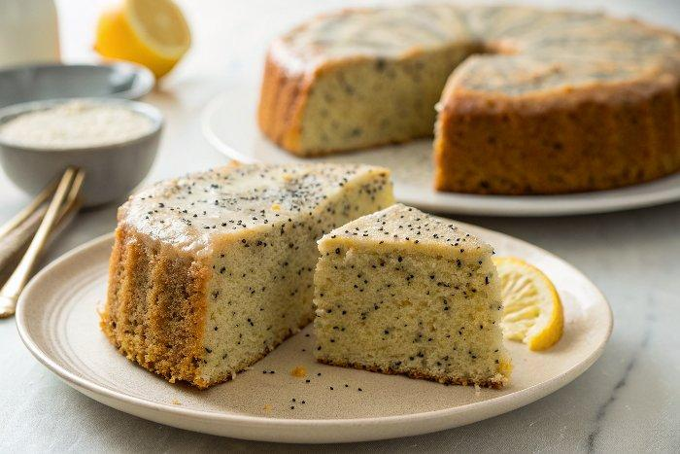

INGREDIENTS  - 1 1/2 cups all-purpose flour  - 1 1/2 cups white whole wheat flour (or substitute regular whole wheat flour or all-purpose flour)  - 1 tbsp baking powder  - 1 tsp baking soda  - 1/2 tsp salt  - 1/2 cup granulated sugar  - Zest of 5 medium lemons  - 10 tbsp unsalted butter (melted and cooled to room temperature)  - 3 large eggs (at room temperature)  - 1 1/4 cups low fat buttermilk (well shaken)  - 2/3 cup whole milk Greek yogurt (about 6 oz)  - 1/2 cup lemon juice (freshly squeezed)  - 1/4 cup honey  - 1 tsp vanilla extract  - 1/4 tsp almond extract  - 3 tbsp poppy seeds  - 1/2 cup granulated sugar  - 1/2 cup lemon juice (freshly squeezed (about 2 large lemons)  - 1 cup (240ml) powdered sugar  - 1 1/2 tbsp lemon juice (freshly squeezed) | PREP  COOK  1. Preheat the oven to 350 degrees. Grease and flour a 10-cup Bundt pan or spray with floured baking spray.  2. Whisk  3. In a large mixing bowl or the bowl of an electric mixer fitted with the paddle attachment, briskly whisk together the all-purpose flour, white whole wheat flour, baking powder, baking soda, and salt.  4. Rub  5. In a separate large bowl, place the granulated sugar. Zest the lemons directly into the sugar, then with your fingers, rub the zest into the sugar until it is moist and fragrant.  6. Add the butter, eggs, buttermilk, Greek yogurt, lemon juice, honey, vanilla extract, and almond extract. Briskly whisk until thoroughly combined.  7. Mix  8. Add the wet ingredients all at once to the dry ingredients. Mix on low speed for 30 seconds, then gradually increase the speed to medium-low and continue mixing until the ingredients are thoroughly combined, about 30 seconds to 1 minute more. Scrape down the bottom and sides of the bowl, then mix again on low speed for 1 minute. Stir in the poppy seeds.  9. Bake  1  0. Scrape the batter into the prepared pan. Bake for 20 minutes, then rotate the pan 180 degrees. Continue baking for 15 to 25 minutes more, until the cake looks nicely browned at the edges and a toothpick inserted in the center comes out clean.  1  1. Cool  1  2. Place the pan on a wire rack set over a baking sheet (the sheet will be to catch cake soak drips). Let the cake cool in the pan for 10 minutes. Use a thin, sharp knife to check around the edges and loosen any that are stuck, then invert the cake onto the rack and let cool completely.  1  3. Heat  1  4. While the cake bakes, prepare the soak. In a small saucepan, heat the lemon juice and sugar together on high, whisking until the sugar dissolves. Set aside.  1  5. Spoon  1  6. Once the cake has been unmolded, spoon half of the soak slowly over the cake so that the cake can absorb it. Wait 1 minute, then slowly spoon on the rest of the soak. Let sit 30 minutes.  1  7. Glaze  1  8. To finish, prepare the glaze. In a small bowl, whisk together the powdered sugar and lemon juice, adding a little more sugar or lemon juice to make a thick but pourable, smooth glaze. Drizzle generously over the cake, allowing some to drip down the sides. Transfer the cake to a serving plate (you also can glaze the cake directly on the serving plate if you like scooping bonus dripped glaze onto slices). Slice and enjoy at room temperature.  PLATING

