CHEESY BAKED PENNE WITH ROASTED VEGGIES  COOK TIME: 45 min  SOURCE:  #comfort-food #baked #vegetable | 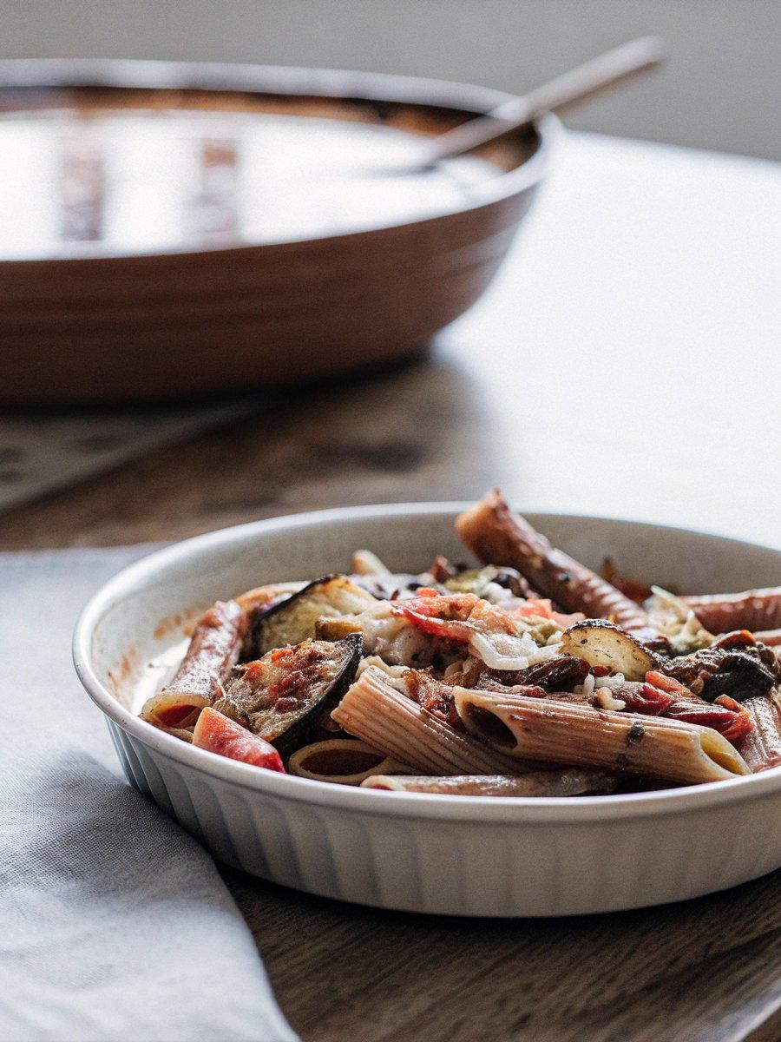

INGREDIENTS  - olive oil spray  - 1 red bell pepper (cored and cut into 1-inch pieces)  - 1 medium (8-oz zucchini, quartered lengthwise and cut into 1-inch cubes)  - 1 medium (8 oz fennel bulb, ends removed and cut into 1-inch pieces)  - 1 cup (240ml) asparagus (cut into 1-inch pieces)  - 1/2 medium red onion (peeled and sliced into 1-inch pieces)  - 6 cloves garlic (peeled and slightly smashed)  - 1 tbsp balsamic vinegar  - 1 tbsp extra-virgin olive oil  - 1/2 tsp kosher salt  - freshly ground black pepper  - 1/2 tsp dried oregano  - 1/2 tsp dried basil  - 12 oz Delallo Gluten-Free Penne  - 8 oz part-skim ricotta  - 1/4 cup chopped fresh parsley  - 1/2 cup grated Pecorino Romano  - 8 oz part-skim mozzarella (shredded)  - 1 25.25 oz jar marinara sauce (we love Delallo Pomodoro) | PREP  COOK  1. Preheat the oven to 450°F (230°C).  2. Spray a large baking sheet with oil, toss the peppers, zucchini, fennel, asparagus, red onion and garlic with balsamic, olive oil, 1/2 teaspoon salt, black pepper, and dried herbs. Roast until tender on the lower rack of the oven, about 15 to 20 minutes stirring halfway, until slightly browned tender.  3. Meanwhile, bring a large pot of salted water to a boil and cook the pasta according to package directions for al dente, (undercooking slightly as it will continue cooking in the oven), drain.  4. In a medium bowl, combine the ricotta, parsley, 6 tablespoons of the Pecorino Romano cheese and half of the mozzarella cheese.  5. Spray a deep 13x9-inch (33x23cm) baking dish with olive oil spray.  6. Put half of the cooked roasted vegetables into the prepared baking dish, then half of the pasta and top with 1 cup (240ml) of the sauce. Spoon the ricotta mixture on top of the sauce in an even layer. Cover with the remaining pasta, then vegetables, then the remaining sauce. Finish with the remaining mozzarella and 2 tbsp Pecorino Romano cheese.  7. Cover with foil and bake in the center of the oven for 25 minutes, or until the mozzarella is melted.  PLATING

