GREEK KALE SALAD WITH CREAMY TAHINI DRESSING  COOK TIME: 5 min  SOURCE:  #healthy #quick #fresh | 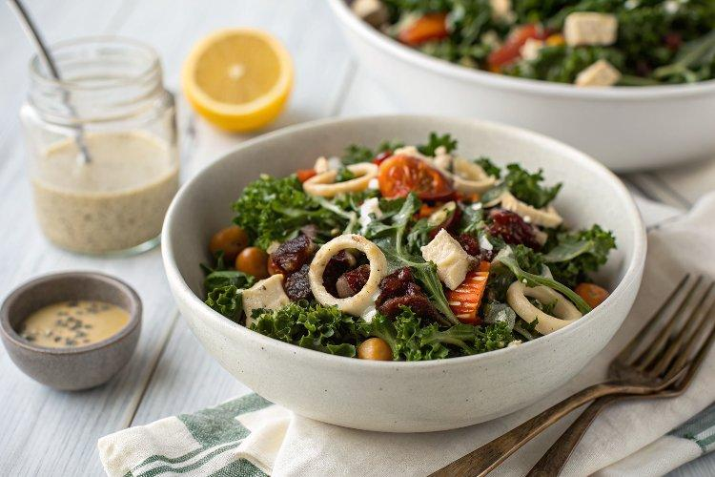

INGREDIENTS  - 1 medium bunch of curly green kale (about 8 oz)  - Fine salt  - 1 can (15 oz) chickpeas, rinsed and drained, or 1 1/2 cups cooked chickpeas  - 1/2 cup thinly sliced Kalamata olives and/or roughly chopped pepper rings  - 1/3 cup oil-packed sun-dried tomatoes, rinsed and drained  - 1/3 cup finely grated Parmesan (optional)  - 1/3 cup raw sunflower seeds*  - 1/4 tsp extra-virgin olive oil  - 1/4 cup tahini  - 3 tbsp lemon juice (from 1 to 1 1/2 lemons)  - 1 tbsp extra-virgin olive oil  - 1 medium clove garlic, pressed or minced  - 1/2 tsp Dijon mustard  - 1/4 tsp fine salt  - 2 tbsp water  - Freshly ground black pepper, to taste | PREP  COOK  1. To prepare the salad: Place the chopped kale in a large serving bowl. Sprinkle it lightly with salt and massage it with your hands by scrunching up large handfuls at a time until it’s darker and more fragrant (this makes the kale more tasty and easier to eat). Add the chickpeas, olives and/or pepper rings, sun-dried tomatoes, and Parmesan (if using). Set aside.  2. To toast the sunflower seeds, combine the seeds with the olive oil and a few dashes of salt in a small skillet over medium heat. Cook, stirring often, until the seeds are fragrant and turning lightly golden at the edges, about 5 minutes. Pour the toasted seeds into the salad bowl.  3. To prepare the salad dressing: In a small liquid measuring cup or bowl, combine the tahini, olive oil, lemon juice, garlic, mustard, and salt. Whisk until blended. Add the water and whisk until blended. Season generously with freshly black pepper, to taste.  4. Pour the dressing into the salad (you might not need quite all of it, but I did). Toss until the salad is evenly coated with dressing. Serve immediately. This salad keeps well in the refrigerator, covered, for up to 3 days.  PLATING

