AIR FRYER SALT AND PEPPER TOFU  COOK TIME: 20 min  SOURCE:  #quick #comfort-food #air-fryer | 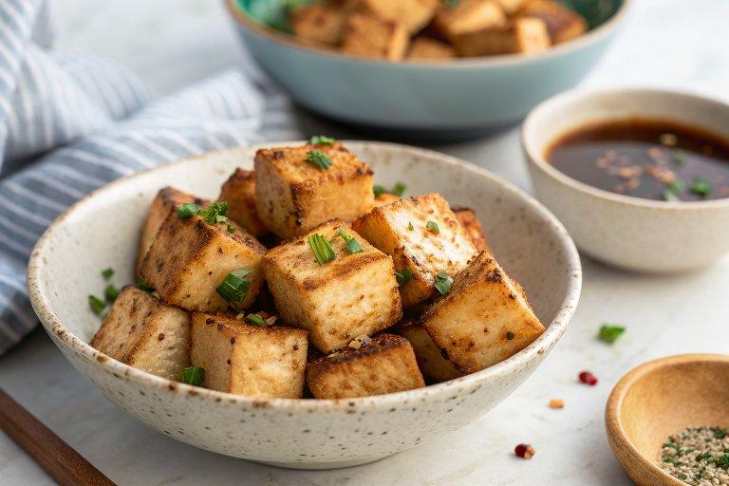

INGREDIENTS  - 1 tsp garlic powder  - 1/2 tsp ginger powder  - 1/2 tsp salt  - 1 block (16 oz / 450 g) firm tofu , cut into 1/2 inch (1 cm) squares  - 1 tbsp peanut oil  - 1 tsp Shaoxing wine  - 1 tsp white pepper powder  - 1/2 tsp brown sugar (or regular sugar)  - 1/2 tsp salt  - 1/8 tsp five-spice powder  - 4 tbsp cornstarch  - Oil spray  - Lemon wedges for garnish (Optional)  - Mayonnaise for garnish (Optional) | PREP  COOK  1. Cooking  2. To marinate the tofu: Combine the garlic powder, ginger powder, and salt in a big bowl. Stir to mix well. Gently pat the tofu dry with kitchen paper towels (no need to press the tofu). Then add it to the spice bowl and gently mix with a spatula. Pour in the peanut oil and Shaoxing wine. Stir again to mix well. Marinate while preparing other ingredients.  3. For the spice mix: Combine the ingredients for the spice mix in a small bowl and stir to mix well.  4. To cook the tofu: When you’re ready to cook, add the cornstarch to the bowl of tofu, 1 tablespoon at a time, and gently mix until the tofu is evenly coated with a thick coating.  5. Heat air fryer to 400°F (200°C)or 10 minutes. Spray the air fryer basket with oil. Place the tofu in the air fryer basket without overlapping. Once the tofu is in the air fryer basket, spray a generous amount of oil to cover the tofu so the cornstarch doesn’t look dry. Cook until the tofu turns light golden, about 8 to 10 minutes. Flip the tofu using a pair of tongs. Spray with a generous amount of oil again. Continue to cook until turning golden brown throughout and some edges have browned, another 8 to 10 minutes. Once done, transfer tofu to a big bowl.  6. While the tofu is still hot, sprinkle about half of the spice mix onto it and gently toss it with a spatula. Adjust the taste by adding more spice mix if needed.  7. Serve hot or at room temperature as an appetizer with the remaining spice mix on the side for dipping. If preferred, serve with lemon wedges and mayonnaise.  PLATING

