THAI PEANUT BUTTER RAMEN  COOK TIME: 30 min  SOURCE:  #comfort-food #quick #noodles | 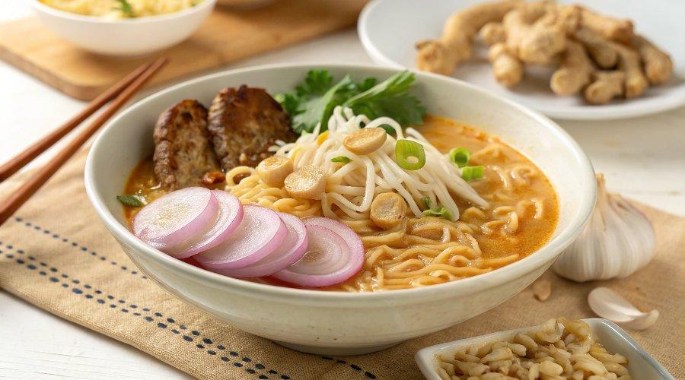

INGREDIENTS  - 1 tbsp peanut oil (or vegetable oil)  - 1/2 onion , sliced  - 3 cloves garlic , sliced  - 2 tsp ginger , minced  - 2 to 4 tbsp Thai red curry paste (*Footnote 1)  - 4 cups (960ml) chicken broth  - 1 can (14 oz / 400 ml) full-fat coconut milk  - 1/3 cup unsweetened natural peanut butter  - 3 tbsp soy sauce  - 1 tbsp sugar  - 1 (8 oz / 225 g) boneless skinless chicken breast (or 2 chicken thighs)  - 8 oz (225 g) mushrooms , sliced  - 1 bell pepper , sliced  - 2 pieces (total 7 oz / 200 g) Instant noodles  - 1 lime , juiced (and more lime wedges to garnish)  - Chopped cilantro for garnish (Optional) | PREP  COOK  1. Heat oil in a 4-quart (3.78-litedutch oven (or heavy poover medium-high heat until hot. Add the onion. Cook and stir for 1 minute.  2. Add the garlic, ginger, and red curry paste. Cook and stir for another minute or so, until it becomes very fragrant and the curry paste evenly coats the veggies.  3. Add the chicken broth. Use a spatula to scrape the bottom of the dutch oven to release the brown bits. Add the coconut milk, peanut butter, soy sauce, and sugar. Stir to mix well. Try to use your spatula to break apart the peanut butter. The peanut butter will melt into the broth once it starts simmering. Taste the broth. You can add more Thai red curry paste if the broth is not spicy enough.  4. Once the broth comes to a boil, add the chicken breast and mushrooms. Turn to medium-low heat and cover. Simmer for 15 minutes, or until the chicken breast is just cooked through.  5. Transfer the chicken to a plate. Shred with two forks. If you find the inside of the chicken is still pink, return it to the pot and cook for a few more minutes, until it just cooked through.  6. Turn to medium-high heat and bring to a boil. Add the instant noodles and bell peppers. Boil according to the package instructions until the noodles turn tender, 2 to 3 minutes.  7. Turn off the heat. Add back the chicken and lime juice. Stir to mix well. Taste the broth. You can adjust the taste by adding more salt. If the broth is too spicy, you can add more sugar to balance the hot taste.  8. Serve hot with more lime wedges and cilantro, if using.  PLATING

