PETER'S LAMB CURRY  COOK TIME: 30 min  SOURCE:  #comfort-food #hearty #spicy | 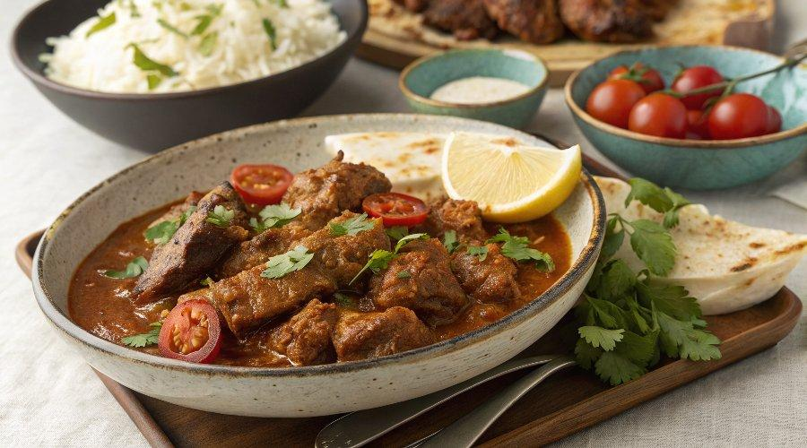

INGREDIENTS  - 1 × hot & fragrant rub (see page 195)  - 2 tbsp unsalted butter  - 2 × 400 g tins of quality plum tomatoes  - 300ml (1.2 cups) stock  - 1.5 kg leg of lamb, bone out, diced  - olive oil  - 1 handful of fresh mint and coriander, chopped  - 250 g natural yoghurt  - 1–2 limes  - 5cm (2-inch) piece of fresh ginger, peeled  - 2 red onions, peeled  - 10 cloves of garlic, peeled  - 2 fresh red chillies  - 1 bunch of fresh coriander | PREP  COOK  PLATING

