RIDICULOUSLY EASY CLASSIC FIESTA GUACAMOLE.  COOK TIME: 5 min  SOURCE:  #quick #fresh #healthy | 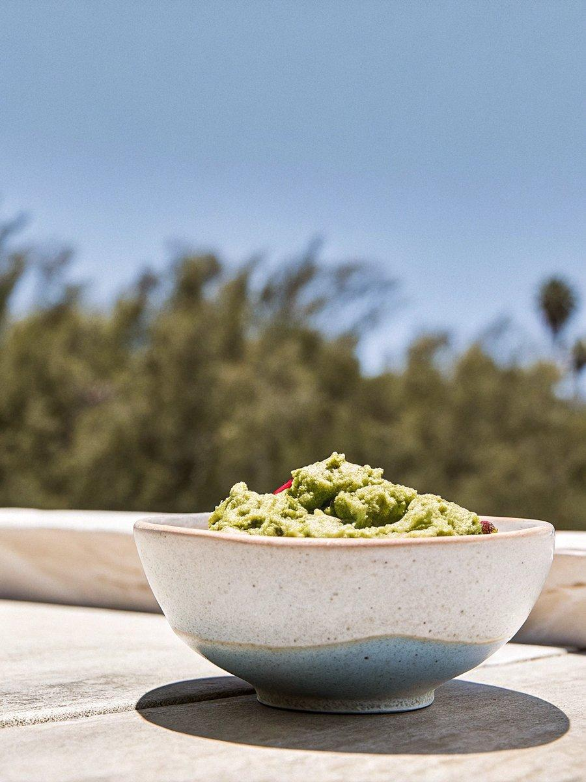

INGREDIENTS  - 3 large ripe hass avocados (halved, seeded and peeled (they have to be ripe!)  - 1 large or 2 small limes (juiced)  - 1/2 tsp ground cumin  - 1/2 a small onion (diced (I normally use a red onion)  - 1 leave large jalapeño (seeded + chopped ( some of the seeds in for a little heat)  - 1 cup (240ml) grape tomatoes (quartered)  - 1/4 cup fresh cilantro (chopped (or more to your liking)  - pinch of salt and pepper | PREP  COOK  1. Add the avocado halves to a medium size mixing bowl. Squeeze the lime juice over the avocados and toss well to coat. Add the cumin. Now grab a fork and lightly mash the avocados. I like to keep my guacamole on the chunky side. Next fold in the diced onion, chopped jalapeño, grape tomatoes, cilantro and a pinch of salt and pepper. Taste and season with more salt and pepper if desired. Grab some chips and dig in!  PLATING

