BLACK SESAME ICE CREAM  COOK TIME: 15 min  SOURCE:  #creamy #sweet #frozen | 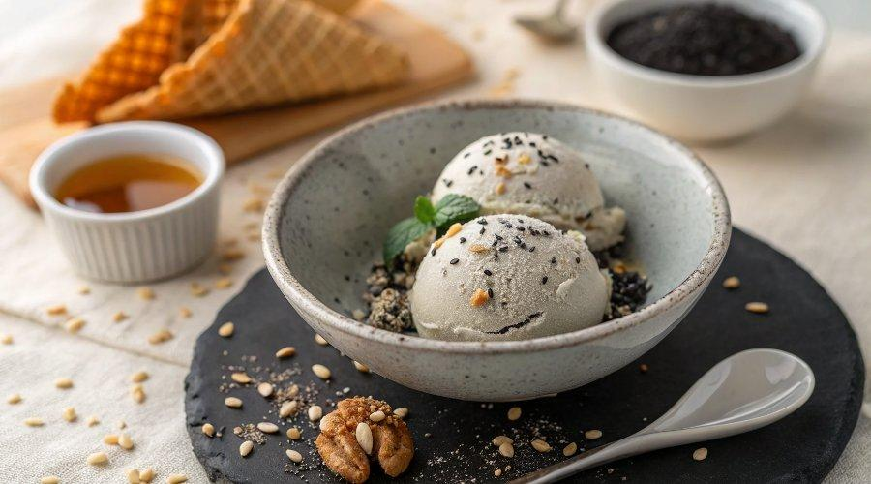

INGREDIENTS  - 2 Tbsp toasted black sesame seeds  - 1 2/3 cups whole milk  - 1/3 cup sugar  - 3 large egg yolks  - 2 Tbsp honey  - 3 Tbsp black sesame paste (or learn How to Make Black Sesame Paste from scratch)  - 1 tsp pure vanilla extract  - 200 ml heavy (whipping) cream ( 3/4 cup + 4 tsp) 3/4 4  - 1/8 tsp Diamond Crystal kosher salt | PREP  COOK  1. Before You Start…Please note that this recipe requires 8+ hours of chilling, churning, and freezing time.  2. Gather all the ingredients.  3. If the black sesame seeds are not roasted yet, put the sesame in a (nonstick) frying pan over medium heat and stir until they start popping. They will release a nutty aroma. Remove from the heat and cool.  4. Grind 2 Tbsp toasted black sesame seeds very finely.  5. Whisk ⅓ cup sugar and 3 large egg yolks together until pale yellow.  6. Add in 2 Tbsp honey, the ground black sesame seeds, and 3 Tbsp black sesame paste. Whisk until well combined.  7. Microwave 1⅔ cups whole milk until hot throughout (or bring it to simmer in a small pot) and add to the sesame mixture in a slow stream. Mix at low speed for 30 seconds.  8. Transfer the mixture into the small pot. Heat the mixture over medium-low heat, stirring constantly, until the custard thickens and reaches around 176ºF (80ºC). Don’t exceed 181ºF (83ºC) since the egg yolk will cook. To avoid salmonella, the egg must be cooked for at least 1 minute over 167ºF (75ºC).  9. Remove from heat and cool down the pot in a large bowl filled with iced water. Add 1 tsp pure vanilla extract.  1  0. Clean the stand mixer bowl and now whisk together 200 ml heavy (whipping) cream (¾ cup + 4 tsp) and ⅛ tsp Diamond Crystal kosher salt until peaks form.  1  1. Add the whipped cream into the cooled sesame mixture.  1  2. Fold in but do not overmix it. Chill the mixture in the refrigerator for several hours (or overnight) until completely cold.  1  3. Process the mixture in your ice cream maker according to manufacturer’s instructions (usually about 25 minutes). Transfer the ice cream to an airtight container and freeze it for several hours before serving.  1  4. If you are not going to use an ice cream maker, then transfer the mixture to a container and put it in a freezer. Stir every few hours (3–4 times) to break up the ice crystals until it’s completely frozen.  PLATING

