YAKISOBA WITH MALONY GLASS NOODLES  COOK TIME: 20 min  SOURCE:  #quick #comfort-food #stir-fry | 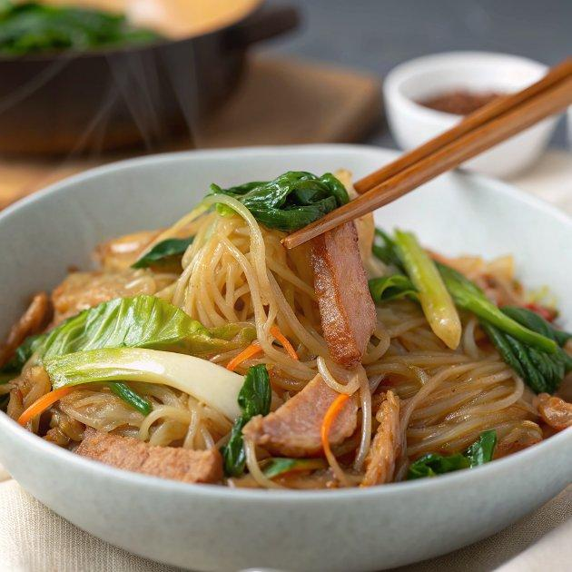

INGREDIENTS  - 6 oz green cabbage (roughly 4 leaves) 4  - 3.5 oz Malony (glass noodles) (1 package; other types of glass noodles may stick/clump, so I highly recommend using Malony) 1  - 1 Tbsp neutral oil  - 4 oz thinly sliced pork loin  - Diamond Crystal kosher salt  - freshly ground black pepper  - 4 oz bean sprouts (handful)  - 4 Tbsp Worcestershire sauce (I used Lea & Perrins made for the US market that is gluten-free; the UK version is NOT gluten-free)  - 2 Tbsp ketchup  - 1 Tbsp oyster sauce (use GF oyster sauce for gluten-free)  - 1 Tbsp soy sauce (use GF soy sauce for gluten-free)  - 1 Tbsp sake  - aonori (dried green laver seaweed)  - pickled red ginger (beni shoga or kizami beni shoga) (you can make homemade Beni Shoga) | PREP  COOK  1. Bring a big pot of water to a boil over medium-high heat. In a bowl, mix all the ingredients for the homemade yakisoba sauce: 4 Tbsp Worcestershire sauce, 2 Tbsp ketchup, 1 Tbsp oyster sauce, 1 Tbsp soy sauce, and 1 Tbsp sake. Set aside.  2. Remove the tough core of 6 oz green cabbage and chop into bite-size pieces.  3. When the water is boiling, cook 3.5 oz Malony (glass noodles) for 6 minutes, stirring occasionally. Once it‘s done, drain completely.  4. When you start boiling the noodles, heat 1 Tbsp neutral oil in a nonstick frying pan over medium heat. When the pan is hot, add 4 oz thinly sliced pork loin.  5. Season the pork with Diamond Crystal kosher salt and freshly ground black pepper. Cook, stirring occasionally, until no longer pink.  6. Add the cabbage and stir-fry for 2 minutes.  7. Then, add 4 oz bean sprouts and cook for 2 minutes or until the cabbage is tender.  8. Add the cooked Malony to the pan and stir-fry for 2 minutes. Combine well with the rest of the ingredients (a pair of tongs is helpful to toss all the ingredients together).  9. Pour the homemade yakisoba sauce into the pan and toss it all together.  1  0. To Serve  1  1. Transfer the Yakisoba with Malony Glass Noodles to individual plates. Top it with aonori (dried green laver seaweed) and pickled red ginger (beni shoga or kizami beni shoga). Serve immediately.  1  2. To Store  1  3. You can keep the leftovers in an airtight container and store in the refrigerator for up to 2 days and in the freezer for 2 weeks. You may want to re-season the noodles to loose up when you're reheating.  PLATING

