AIR FRYER SALT & PEPPER CHICKEN  COOK TIME: 32 min  SOURCE:  #quick #comfort-food #air-fryer | 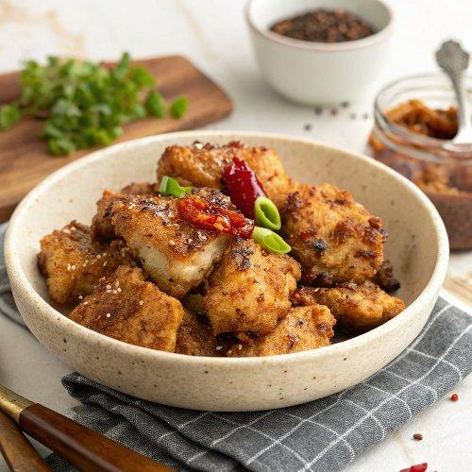

INGREDIENTS  - 400 g boneless, skinless chicken thighs roughly chopped  - 1 1/2 tsp cornflour  - 3/4 tsp Szechuan pepper crushed (or use black pepper)  - 1 tsp Chinese five-spice powder  - 1 red chilli finely chopped  - 2 red peppers roughly chopped  - 6 spring onions 4 roughly chopped, 2 sliced on the diagonal  - 1 1/2 tsp olive oil  - 2 pak choi leaves separated  - 1/2 tbsp honey  - 1 tbsp Shaohsing rice wine  - cooked rice and soy sauce, to serve | PREP  COOK  1. Heat the air fryer to 200C. Combine the chicken with the cornflour, ¾ tsp salt, the Szechuan pepper and five-spice powder. Tip into the air fryer basket and cook for 15 mins until cooked through. Tip onto a plate and set aside.  2. Tip the chilli, peppers and roughly chopped spring onions into a bowl and toss with the olive oil, then tip into the air fryer basket and cook for 10 mins. Add the pak choi leaves and cook for a further 5 mins. Scoop everything from the air fryer into a bowl along with the chicken, honey and rice wine. Stir together, then return it all to the air fryer and cook for 2 mins. Scatter over the remaining spring onions and serve with the cooked rice and soy sauce.  3. Good Food deserves great wine, so we've partnered with Laithwaites Wine to help you discover the perfect wine and food pairings. Pair your air fryer salt and pepper chicken with La Chica Bonita low-alcohol sparkling and save 20% when you spend £75 using code 20OFF  PLATING

