VEGAN STUFFING  COOK TIME: 2h  SOURCE:  #comfort-food #holiday #vegetarian | 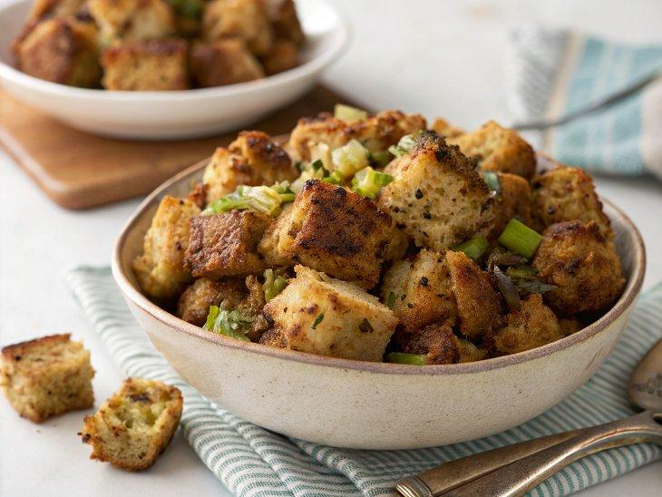

INGREDIENTS  - 2 lb hearty sourdough or french bread, cut into 3/4-inch (10cm) cubes (about 14 cups cubed)  - 3-4 1/2 cups vegetable broth (I used Better Than Bouillon No-Chicken )  - 2 tbsp cornstarch  - 3/4 tsp salt, or more to taste  - 1/2 tsp black pepper  - 4 tbsp vegan butter (or olive oil)  - 2 cups (480ml) diced yellow onion (about 2 small or 1 large onion)  - 2 cups (480ml) chopped celery  - 3 cloves garlic, minced  - 1/3 cup fresh parsley, chopped small  - 1 tsp dried sage  - 2 tsp dried thyme  - 1 tsp dried marjoram | PREP  COOK  1. Dry the breadcrumbs: Preheat the oven to 250°F (120°C) and spread the bread cubes evenly onto two large rimmed baking sheets. Place in the oven and bake for about 50-60 minutes, rotating the pans a few times (every 20 minutes). Remove from the oven. Set aside to cool.  2. Increase the oven temperature to 375 degrees and make sure one of the racks is in the center of the oven.  3. In a large bowl or glass measuring cup, whisk 3 cups (720ml) of the broth with the cornstarch, salt and pepper until combined. Set aside.  4. In a large skillet, melt the vegan butter over medium heat. Add the onion and celery and sauté until translucent and softened, about 5-6 minutes. Add the garlic and cook 1 more minute. Remove from heat.  5. In a very large bowl, add the dried bread crumbs, parsley, sage, thyme and marjoram. Now add the onion/celery mixture.  6. Give the broth mixture once last whisk and then slowly start drizzling it in to the bowl with the bread and toss immediately. Pour in more broth while tossing until the bread is just barely soaked though. You don’t want them to be too wet or too dry. I used about 4 cups (960ml), but it will depend on the bread you use.  7. Add to a greased 9x13-inch (23x33cm) baking dish and spread into an even layer. Cover with foil and bake for 30 minutes, then remove the foil and cook uncovered for about 20 more minutes. If you want it a little more browned on top, broil for just a few minutes but watch carefully so it doesn't burn. Enjoy!  8. MAKE AHEAD OPTION: You can prepare the stuffing a day in advance, or longer if you freeze it. To make ahead, dry out the bread, sauté the vegetables and mix it all together with the broth/cornstarch mixture + herbs. Place in the casserole dish, then cover and refrigerate for a day, or freeze for longer. When ready to serve, pop it in the oven and bake as directed, plus a little extra time especially if you froze it.  PLATING

