SALTED CARAMEL APPLE UPSIDE DOWN CAKE  COOK TIME: 45 min  SOURCE:  #sweet #comfort-food #baking | 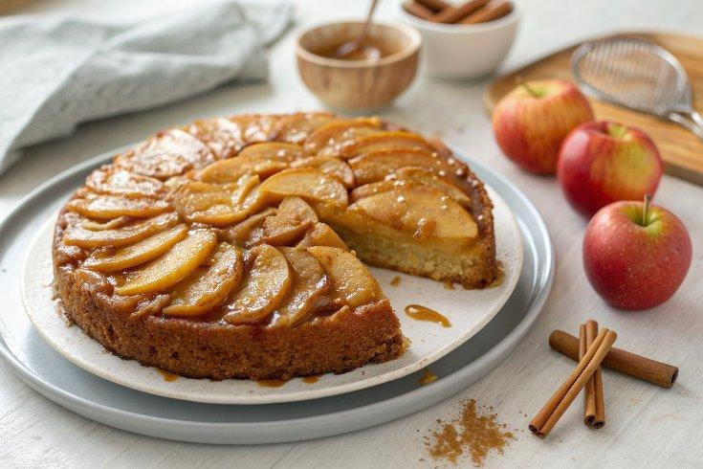

INGREDIENTS  - 2 cups (480ml) very thinly sliced apples (3-4 apples)  - 1/2 cup salted butter  - 2/3 cup brown sugar  - 1 tsp cinnamon  - 1/2 tsp nutmeg  - 1/4 tsp ground cloves  - 1 tsp vanilla extract  - 1/2 cup salted butter  - 1 cup (240ml) brown sugar  - 2 large eggs  - 1/4 cup milk  - 1 1/2 cups all-purpose flour  - 1 tsp baking powder  - 1/2 tsp cinnamon  - Sea salt for topping | PREP  COOK  1. Generously grease a round 9-inch (23cm) cake pan. Slice the apples with a mandoline to get them super thin, like paper. Or if that’s not possible, as close to paper as possible. 🙂  2. Sauce  3. Melt the butter in a medium saucepan. Add the brown sugar, cinnamon, nutmeg, cloves, and vanilla. Keep over medium heat and cook for about 3 minutes until smooth and thickened slightly. Pour the caramel into the greased cake pan and top with the apple slices. Sally does this the other way around but I loved how it turned out with the caramel on the outside.  4. Cake  5. Preheat the oven to 325 degrees. Beat the remaining butter and brown sugar until creamy. Add the eggs and milk and beat until incorporated. Stir in the flour, baking powder, and cinnamon. Pour the cake on top of the caramel and apple layer in the cake pan.  6. Bake for 45 minutes. Let cool for 10 minutes (Sally says 10 minutes is just right, and mine came out of the pan perfectly at 10). Invert onto a plate and tap the top until the cake comes out onto the plate. Sprinkle with sea salt and serve with vanilla ice cream. Die and go to caramel apple heaven. The end.  PLATING

