VALENTINE’S DAY CAKE  COOK TIME: 40 min  SOURCE:  #celebration #sweet #baked | 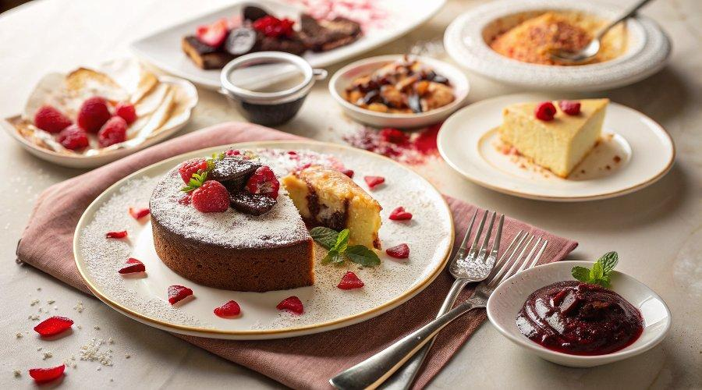

INGREDIENTS  - Butter, (for greasing)  - 1 3/4 cups (225 g) all-purpose flour, (plus more for pans)  - 2 cup (480ml)s (400 g) granulated sugar  - 3/4 cups (64 g) unsweetened natural cocoa powder  - 2 tsp baking soda  - 1 tsp baking powder  - 1 tsp fine sea salt  - 1 cup (240ml) buttermilk, (at room temperature )  - 1/2 cup fresh vegetable oil  - 2 large eggs, (at cool room temperature)  - 1 tsp pure vanilla extract  - 1 cup (240ml) freshly brewed hot coffee  - 6 cup (1440ml)s (750 g) powdered sugar, (sifted)  - 4 sticks (452 g) unsalted butter, (at room temperature)  - 2/3 cup seedless strawberry preserves  - 1/2 tsp fine sea salt  - 2 tsp pure vanilla extract  - Red gel food coloring, (if desired)  - Chocolate-Covered Strawberries, | PREP  COOK  1. For the cake:  2. Preheat the oven to 350°F (175°C). Butter and flour 2 (8-inch) round cake pans.  3. Sift the flour, sugar, cocoa, baking soda, baking powder, into the bowl of an electric mixer fitted with a paddle attachment. Add in the salt and whisk to combine.  4. In a large measuring cup or small bowl, combine the buttermilk, oil, eggs, and vanilla. With the mixer on low speed, slowly add the wet ingredients to the dry. With the mixer still on low, add the hot coffee and stir just to combine, scraping the sides and bottom of the bowl with a rubber spatula. Don’t overmix, the batter should be very thin and runny.  5. Divide the batter among the prepared pans and bake for 35 to 40 minutes, until a cake tester comes out clean. The cakes may sink slightly in the middle because they're so moist. Cool in the pans for 30 minutes, then carefully turn them out onto a cooling rack and cool completely. Freeze or refrigerate until firm to the touch.  6. For the buttercream:  7. In the bowl of a stand mixer fitted with the paddle attachment, mix together the sugar and butter. Mix on low speed until well blended and then increase the speed to medium and beat for another 3 minutes until ultra light and smooth. Add in the strawberry preserves, salt, and vanilla and beat on medium for 1 minute. Add about 1/4 teaspoon gel food coloring, if using, and beat until the buttercream is evenly colored. Add more coloring if desired.  8. Assemble the cake:  9. Place the first cold cake layer, flat side up, on a flat surface or cake pedestal. Using an offset spatula, spread about 1/3 of the frosting all over the top of the cake, pushing it all the way past the edges.  1  0. Place the second cake layer on top, flat side up, and spread a very thin coating of frosting all over the top and sides of the cake, to make a crumb coating. When scraping away excess frosting, be careful not to add the crumb frosting back in with the clean frosting. Freeze or refrigerate the cake until the frosting is firm.  1  1. Once the frosting is firm, spread the remaining frosting evenly over the cake, scraping away excess frosting and smoothing imperfections with the offset spatula. Garnish with sprinkles and chocolate-covered strawberries before serving, if desired.  1  2. The frosted cake can be stored at room temperature for 1 day or in the fridge for up to 3 days.  PLATING

