MULTIGRAIN BREAD ROLLS (BRÖTCHEN)  COOK TIME: 30 min  SOURCE:  #healthy #homemade #fiber-rich | 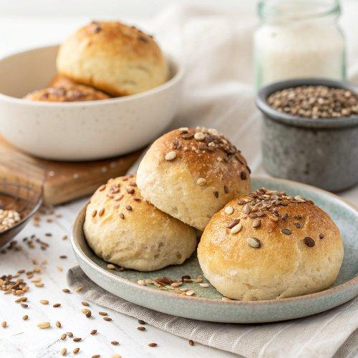

INGREDIENTS  - 15 g whole flax seeds  - 15 g whole sunflower seeds  - 15 g whole chia seeds  - 60 g hot water  - More seeds (to sprinkle)  - 120 g brown rice flour  - 70 g chickpea flour (see notes)  - 25 g tapioca flour (see notes)  - 15 g psyllium husk powder  - 15 g ground chia seeds  - 3/4 tsp salt  - 1 1/2 tsp baking powder  - 240 g water  - 15 g apple cider vinegar | PREP  COOK  1. You can watch the video in the post for visual instructions.Add the whole seeds to a small/medium bowl and pour hot water over them. Mix with a spoon and let it rest for about 10 minutes.  2. Preheat the oven to 360°F (180°C)ahrenheit (180 degrees Celsius) and line a baking sheet with parchment paper or a silicone mat.  3. Meanwhile, add the brown rice flour, chickpea flour, tapioca flour, psyllium husk powder, ground chia seeds, salt, and baking powder to a large mixing bowl.  4. Add the water, apple cider vinegar, and the wet seed mixture and stir with a spoon. Then use your hands to knead the dough for a few minutes. You can also use a hand mixer.  5. Divide the dough into 6 equal parts and shape each into a roll.  6. Sprinkle the parchment paper (or silicone mat) with a thin layer of seeds of choice and place the 6 rolls on it. Sprinkle the tops with more seeds.  7. Bake in the oven for 30-40 minutes and enjoy!  PLATING

