ROASTED BRUSSELS SPROUTS  COOK TIME: 25 min  SOURCE:  #healthy #quick #roasted | 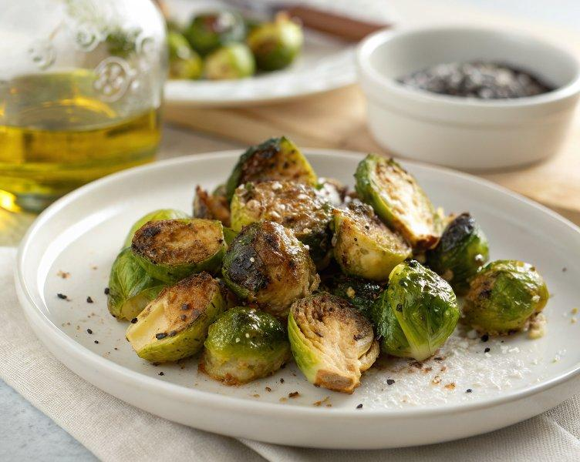

INGREDIENTS  - 1 lb. Brussels sprouts ($2.99)  - 1 Tbsp olive oil ($0.12)  - 1/4 tsp salt ($0.02)  - 1/4 tsp garlic powder ($0.02)  - 1/4 tsp freshly cracked black pepper ($0.02) | PREP  COOK  1. Wash  2. Preheat the oven to 400ºF. Wash and dry the Brussels sprouts well. Trim off any dry ends and cut each Brussels sprout in half.  3. Season  4. Place the cut Brussels sprouts on a parchment lined baking sheet. Don't over crowd the sheet! Drizzle with olive oil and sprinkle with salt, garlic powder, and pepper.  5. Toss until well coated in the oil and seasoning. Turn each Brussels sprout so that the cut side facing down.  6. Roast for about 25 minutes, or until they have achieved the level of browning that you like. The total time may change depending on the size of your Brussels sprouts. You can give them a stir after about 20 minutes to see how much they have browned on the cut side. No need to flip them all back over for the final few minutes.  7. Taste one Brussels sprout and adjust the salt or pepper to your liking, then serve hot.  PLATING

