CLASSIC VEGAN PROTEIN SMOOTHIE (WITH OR WITHOUT PROTEIN POWDER)  COOK TIME: 3 min  SOURCE:  #healthy #quick #smoothie | 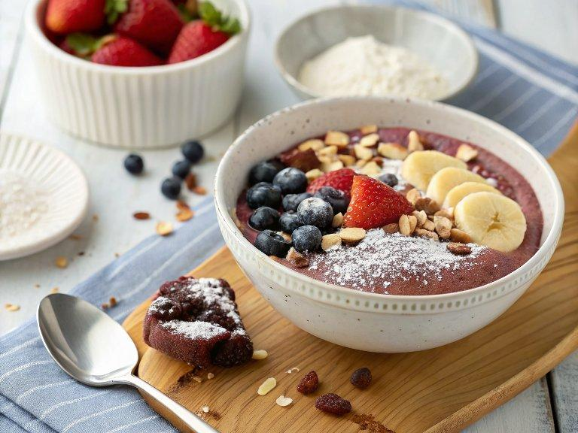

INGREDIENTS  - 1 serving vegan protein ((see notes))  - 1 - 1 1/2 cups cup plant-based milk ((see notes))  - 1 heaping cup frozen fruit ((see notes))  - 1 - 2 boosters (optional) ((see notes)) | PREP  COOK  1. Choose 1 - 2 vegan protein options (see notes). Then choose your plant-based milk option. Some kinds of plant-based milk have a lot of extra protein so it's a great way to add even more protein to your smoothie if desired (see notes for a guide).  2. To a blender, add your protein option, 1 cup (240ml) of plant-based milk, your frozen fruit of choice, and any optional boosters you like. Blend until smooth and creamy. If the smoothie is too thick, add up to 1/2 cup more plant-based milk until you reach your desired consistency.  PLATING

