BILLY'S BOLOGNESE  COOK TIME: 3h 30m  SOURCE:  #comfort-food #hearty #pasta | 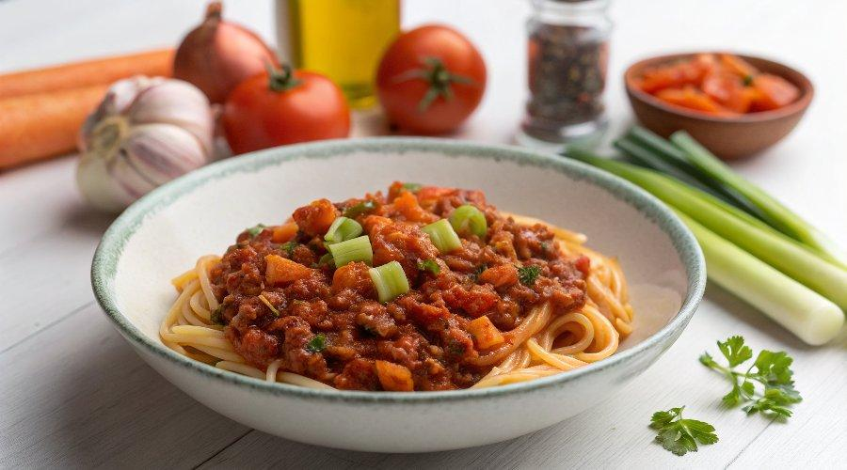

INGREDIENTS  - 2 onions  - 2 cloves of garlic  - 1 large carrot  - 1 stick of celery  - 1 courgette  - olive oil  - 500 g lean beef mince  - 2 x 400 g tins of plum tomatoes  - 450 g dried spaghetti  - Cheddar or Parmesan, to serve | PREP  COOK  1. Place a large casserole pan on a medium-low heat.  2. Peel the onions and garlic, trim the carrot, celery and courgette. Finely chop or coarsely grate all the veg, then stir it into the pan with 1 tablespoon of olive oil.  3. Cook for 10 to 15 minutes, or until the vegetables are soft and sweet, stirring occasionally.  4. Add the mince, breaking it up with a wooden spoon, then turn the heat up a little and cook for 5 minutes, stirring regularly until the meat is browned and the veg is nicely golden.  5. Scrunch in the tomatoes through clean hands, then half-fill each tin with water, swirl it around to pick up all the last bits of tomato and pour into the pan.  6. Mash everything up with your spoon, add a pinch of black pepper, reduce the heat to low and leave to cook for 2 to 3 hours, or until thickened and reduced.  7. About 15 minutes before you’re ready to serve, cook the spaghetti in a large pan of boiling salted water according to the packet instructions, then drain. Use tongs to divide between bowls, then spoon over the Bolognese and serve with a good grating of cheese.  PLATING

