CARDAMOM CHICKEN (MASALA MURGH)  COOK TIME: 30 min  SOURCE:  #spicy #comfort-food #chicken | 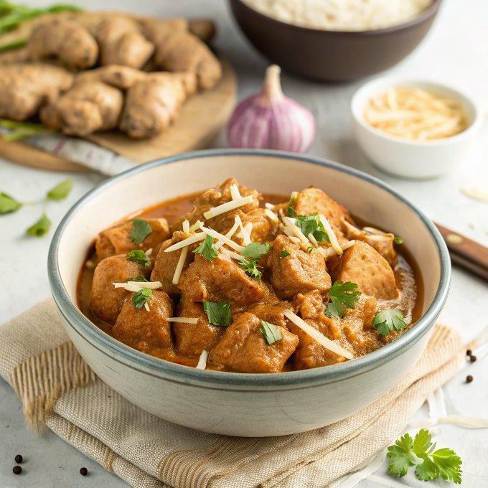

INGREDIENTS  - 1 lb boneless, skinless chicken breast  - 4 tbsp vegetable oil  - 2 cloves garlic (finely minced)  - 1 tbsp peeled and finely grated ginger  - 1 big yellow or white onion (shredded in a food processor)  - 3/4 tsp cumin seeds  - 5 whole green cardamom pods (cracked )  - 1 large ripe tomato (cut into thin wedges )  - 1/4 tsp ground turmeric (or more)  - 1 tsp ground cayenne pepper  - 1 tsp salt  - 1 tsp ground black pepper | PREP  COOK  1. Wash the chicken under cold water and cut it into 3/4-inch (2 cm) pieces. Add the oil to a large skillet and heat it over medium heat. Once the oil is hot, add the garlic, ginger, and onion. Sauté while stirring frequently until the onion turns golden brown, about 5 minutes.  2. Add the cumin seeds and cracked cardamom pods and seeds to the skillet. Stir to combine. Reduce the heat to medium-low, then add the tomatoes, stirring and breaking them down with a spatula. Cover the skillet and cook until the tomatoes are completely soft and mushy, blending with the onion to form a coarse paste, about 5 minutes.  3. Add the turmeric, cayenne pepper, salt, and black pepper. Stir to combine, forming the masala (spice base).  4. Add the chicken and stir to combine. Increase the heat to medium and cook, stirring, until the chicken is completely cooked through and the spice base evenly coats the pieces. Serve immediately with naan or basmati rice.  PLATING

