HOISIN SHRIMP WITH BROCCOLI  COOK TIME: 5 min  SOURCE:  #quick #healthy #seafood | 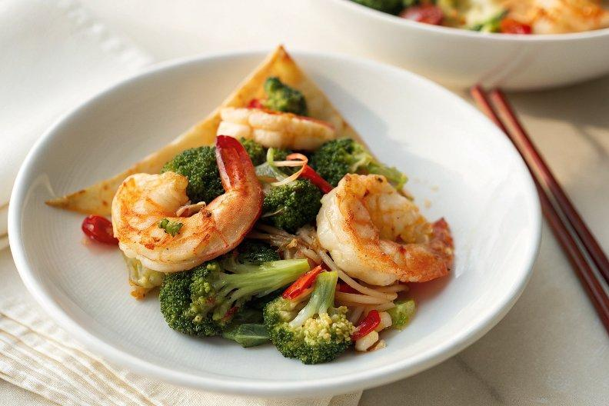

INGREDIENTS  - 12 oz. (340 g) shrimp (shelled and deveined, tail-on)  - 6 oz. (170 g) broccoli florets  - 1 small red bell peppers (cut into pieces)  - 1 1/2 tbsp cooking oil  - 6 slices ginger (peeled)  - White sesame (for garnishing)  - 4 tbsp San-J hoisin sauce  - 1/4 cup water  - 1 tsp cornstarch | PREP  COOK  1. Rinse the shrimp with cold water, then drain and set aside.  2. In a small bowl, mix together the San-J Hoisin Sauce, water, and cornstarch. Stir until well combined, then set aside.  3. Heat a skillet or wok over medium heat. Once it’s heated, add the cooking oil. Sauté the ginger until aromatic, then add the shrimp. Stir and toss the shrimp until the surface turns white. Add the broccoli florets and red bell peppers, and stir to combine well.  4. Add the sauce to the skillet or wok, stirring continuously with all the ingredients. Let it simmer until it reduces to a thicker consistency. Turn off the heat, transfer the shrimp to a serving platter, and top with white sesame seeds. Serve immediately.  PLATING

