SWEET POTATO SALAD  COOK TIME: 45 min  SOURCE:  #healthy #quick #comfort-food | 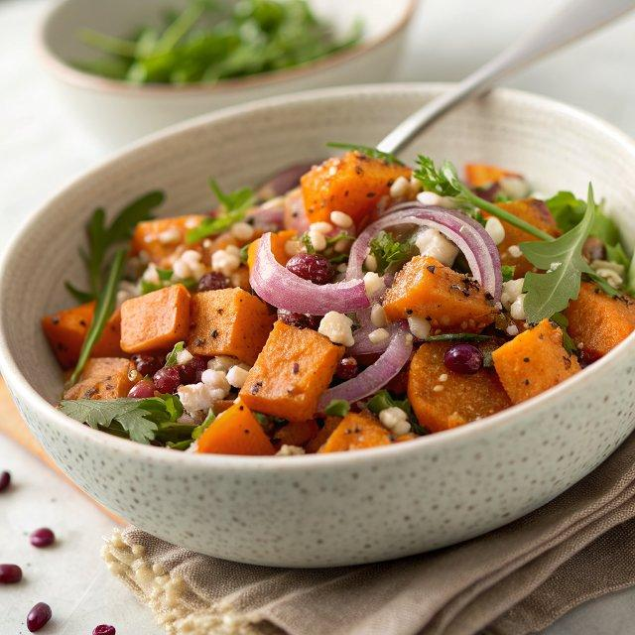

INGREDIENTS  - 1 3/4 lb small to medium sweet potatoes  - Extra virgin olive oil  - Salt  - Ground black pepper  - 1/2 cup pearl couscous  - 1/2 cup boiling water  - 4 cups (960ml) baby arugula  - 1/2 red onion (thinly sliced)  - 1/2 cup crumbled feta cheese  - 1/2 cup slivered almonds  - 2 tbsp honey  - 5 tbsp lemon juice  - 1 clove garlic (minced (optional)  - 1 tsp Dijon Mustard  - 1/2 cup extra virgin olive oil  - Salt and pepper (to taste) | PREP  COOK  1. Get ready. Preheat your oven to 390°F (200°C). Line one large baking tray with parchment paper.  2. Prepare the sweet potatoes. Peel and cut the sweet potato into bite-size 3/4-inch (10cm) pieces. Place the sweet potato in a bowl and add ¼ cup of extra virgin olive oil, and a big pinch each salt and pepper. Toss until the sweet potatoes are evenly coated with oil.  3. Bake the sweet potatoes. Place them in a single layer on the baking tray and sprinkle with additional salt. Bake for 30-45 minutes, tossing halfway, until the potatoes are soft, caramelized, and slightly charred. Set aside to cool.  4. Cook the couscous. Drizzle 1 tablespoon of extra-virgin olive oil into a small pot or bowl, then add the couscous and salt. Mix and top with boiling water. Cover with a lid or plastic wrap and let it sit until the couscous has absorbed all the liquid. This should take 5-10 minutes. Uncover and fluff up using a fork. Set aside to cool completely.  5. Toast the almonds. Add the almonds to a dry pan and toast them over low to medium heat, tossing until golden brown—it should take 5 to 10 minutes. Keep an eye on them, as they can brown very quickly. Set aside to cool.  6. Make the dressing. Combine the honey, lemon juice, garlic, Dijon mustard, olive oil, and a pinch each of salt and pepper in a small bowl. Whisk to combine.  7. Dress and serve. To assemble, use a large platter (rather than a deep bowl). Spread the arugula in an even layer on the bottom. Whisk the dressing again to recombine and add a few teaspoons to the arugula; mix gently to coat. Layer the roasted sweet potato and couscous on top. Scatter on the red onion, feta cheese, and toasted almonds. Drizzle with the dressing and serve immediately.  PLATING

