CHINESE JUJUBE TEA (红枣茶)  COOK TIME: 15 min  SOURCE:  #quick #comfort-food #healthy | 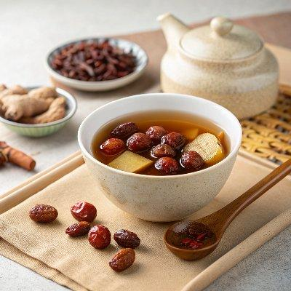

INGREDIENTS  - 60 g (6 big) jujubes  - 5 g (1 tbsp) goji berries  - 1 thumb ginger , sliced  - 1 tbsp brown sugar (or to taste) | PREP  COOK  1. Place the jujubes in a large bowl and water to cover. Soak for 10 minutes. Then gently rub the jujube surface to remove any dust. Drain and discard the water. Halve the jujubes using a paring knife, then remove the cores.  2. Rinse the goji berries with water. Gently rub to remove any dirt from the surface.  3. Add the jujubes, goji berries and ginger to a small pot. Add 4 cups (960ml) of water. Cook over medium-high heat until boiling. Turn to medium-low heat and simmer for 10 minutes.  4. Once done, strain the tea using a small strainer. Press the jujubes to release as much liquid as possible.  5. Add the brown sugar and stir to mix well. Taste the tea and add more sugar if needed. Serve hot.  PLATING

