CRISPY PORK & BROCCOLI NOODLES  COOK TIME: 20 min  SOURCE:  #quick #comfort-food #stir-fry | 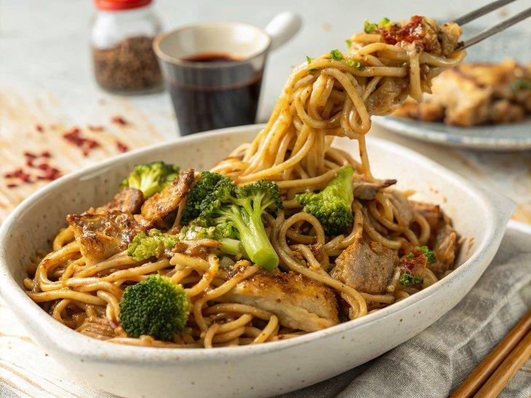

INGREDIENTS  - olive oil  - 1 bulb of garlic  - 4cm (2-inch) piece of ginger  - 1 tsp dried chilli flakes  - 2 tbsp light soy sauce  - red wine vinegar  - 250 g minced pork  - 500 g plain flour, plus extra for dusting  - 1 head of broccoli (375 g)  - 1 small red onion  - 1 tbsp runny honey  - 30 g salted roasted peanuts | PREP  COOK  1. Peel and finely chop the garlic and ginger, then place half in a heat-proof dish with the dried chilli, and put the rest aside for later.  2. Place a large non-stick frying pan on a high heat with 4 tablespoons of olive oil. As soon as the oil starts to shimmer, pour it into the heatproof bowl to make a fragrant oil. When the sizzling subsides, add the soy sauce and 1 tablespoon of red wine vinegar, then leave to sit – the flavour will get better and better.  3. Return the pan to a medium-low heat and add the pork, breaking it up with a wooden spoon. Cook for 5 minutes stirring occasionally, until golden and crispy.  4. To make the noodles, pile the flour into a mixing bowl and slowly add 300ml (1.2 cups) of water to bring it together into a dough. Knead for just a couple of minutes, or until soft, shiny and elastic. On a flour-dusted surface, use a rolling pin to roll out the pasta to about 2mm thick – don’t worry if it tears or looks wonky, this dough is very forgiving. Dust it well with flour, then loosely roll it up. Use a sharp knife to slice it at 2cm (1-inch) intervals, then toss it with your hands to separate the strands.  5. Meanwhile, pop a large pan of salted water on to boil. Cut the broccoli into mouth-sized florets, cracking open any big ones (this will help with cooking time), then finely slice the stalk. Halve the onion, finely chop and use it in 2 ways – add ¾ to the pork now, and add the remaining to a bowl with a splash of vinegar and some salt to make a quick pickle to be used as a garnish.  6. When the pork is golden, increase the heat to medium-high, and stir through the remaining ginger and garlic. Add the broccoli to the salted water and cook for 5 minutes, with the lid on, then remove with a slotted spoon.  7. Return the salted water back to the boil. Add the noodles, give them a stir and cook with the lid on for 3 minutes.  8. At the last minute, stir the honey through the pork (this will stop it burning) to give the meat sweetness and shine, then remove from the heat.  9. When the noodles are cooked, drain and toss them with the broccoli and the flavoured oil and divide between plates. Pour over the pork juices and scatter over the crispy pork bits from a height. Bash up and sprinkle over the peanuts, scatter with the quick-pickled onions, and serve straight away.  PLATING

