LEMON GINGER GIMLETS  COOK TIME: 5 min  SOURCE:  #refreshing #cocktail #quick | 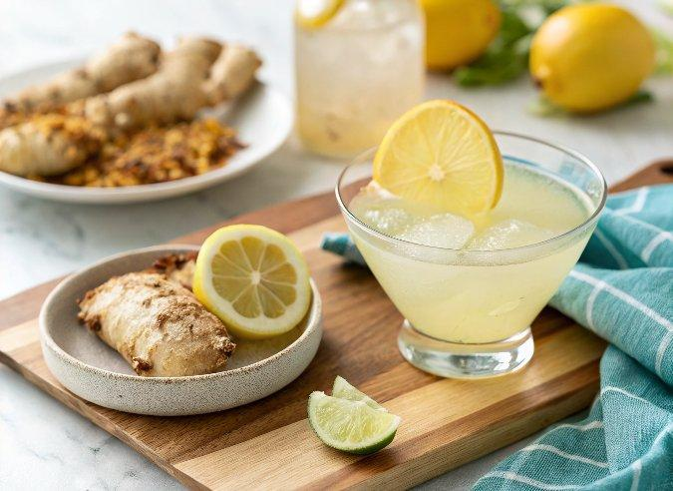

INGREDIENTS  - 1/4 cup gin  - 1 tbsp meyer lemon juice  - 1 tbsp agave nectar  - splash of ginger juice *  - splash of sparkling water  - lemon peels, for garnish | PREP  COOK  1. Fill a cocktail shaker with ice. Add the gin, lemon juice, agave nectar, ginger juice, and a handful of crushed ice ice. Shake for 20 seconds, then strain into two glasses. Top with a splash of sparkling water. Garnish with lemon peel.  PLATING

