EASY STRAWBERRY BREAD  COOK TIME: 1h  SOURCE:  #quick #comfort-food #baking | 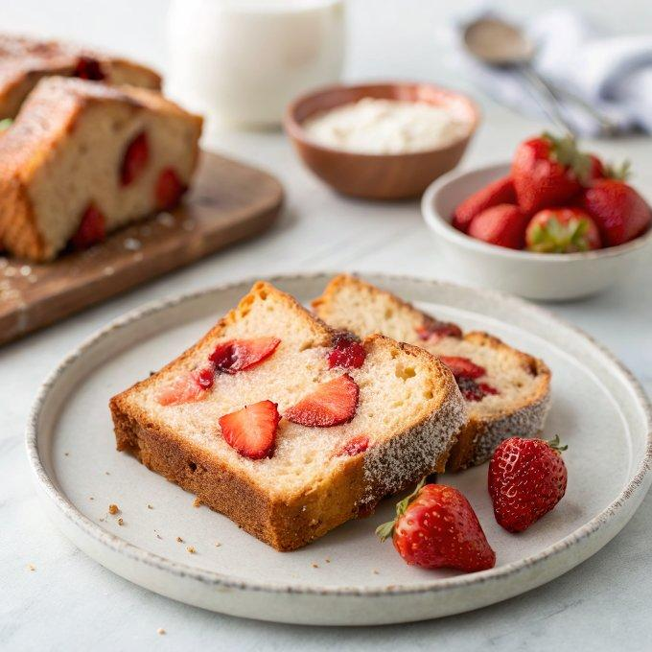

INGREDIENTS  - 2 cup (480ml)s (250 g) all-purpose flour (spooned & leveled)  - 1 and 1/2 tsp baking powder  - 1/4 tsp baking soda  - 1/2 tsp salt  - 1 large egg, at room temperature  - 3/4 cup (150 g) granulated sugar  - 1/4 cup (50 g) packed brown sugar  - 3/4 cup (180 ml) buttermilk, at room temperature*  - 1/3 cup (80 ml) vegetable oil or melted coconut oil  - 2 tsp pure vanilla extract or vanilla bean paste  - 1 and 1/2 cups (230 g) chopped fresh strawberries, tossed in 1 tbsp of flour  - 1/2 cup (60 g) confectioners’ sugar, sifted  - 1 tbsp (15 ml) heavy cream or milk  - 1/4 tsp pure vanilla extract or vanilla bean paste | PREP  COOK  1. Preheat oven to 350°F (177°C). Grease an 8×4-inch (10cm) loaf pan like this one or this one with nonstick spray. Set aside.  2. Make the bread:  3. In a large bowl, whisk the flour, baking powder, baking soda, and salt together until combined. Set aside.  4. In a medium bowl, whisk the egg, granulated sugar, brown sugar, and buttermilk together until combined. Make sure there are no brown sugar lumps remaining. Whisk in the oil and vanilla.  5. Slowly pour the wet ingredients into the dry ingredients and gently whisk until there are no more lumps. Avoid over-mixing. Gently fold in the strawberries. Pour/spoon batter into prepared loaf pan.  6. Bake for 55–70 minutes, making sure to loosely cover the bread with aluminum foil halfway through to prevent the top from getting too brown. The bread is done when a toothpick inserted in the center comes out clean with only a few small moist crumbs. All ovens vary, so begin checking every 5 minutes around the 55-minute mark.  7. Remove bread from the oven and allow the bread to cool in the pan set on a wire rack for 1 hour. Remove bread from the pan and place the loaf directly on the wire rack to cool completely.  8. Make the icing  9. Whisk the icing ingredients together. (I usually use heavy cream, which promises a thick icing.) Drizzle over bread before slicing.  1  0. Cover and store bread at room temperature for 2 days or in the refrigerator for up to 1 week. Icing seeps into the top of the strawberry bread over time, so expect the tops of the slices to become a little moist.  PLATING

