LEMON RASPBERRY CAKE RECIPE  COOK TIME: 35 min  SOURCE:  #cake #sweet #fruit | 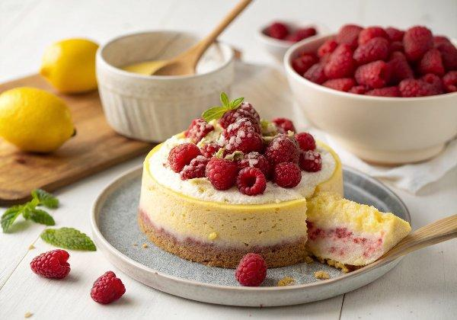

INGREDIENTS  - 9 oz. (approx. 1 1/2 cups) raspberries + 1 tbsp flour  - 4 large eggs, (room temperature)  - 1/3 cup milk (anything but nonfat) (room temperature)  - 2 tbsp lemon juice, (room temperature)  - 1 tbsp lemon zest  - 2 tsp vanilla extract  - 2 cups (480ml) cake flour (see DIY in Notes)  - 1 1/2 cups granulated sugar  - 2 tsp baking powder  - 3/4 tsp salt  - 16 tbsp unsalted butter cut into 16 pieces, (room temperature)  - 16 oz ripe fresh raspberries or frozen thawed raspberries  - 2/3 cup granulated sugar  - 2 1/2 tbsp cornstarch  - 2 1/2 tbsp lemon juice  - 16 oz. full-fat brick style cream cheese, (room temperature (DON'T microwave)  - 1 cup (2 sticks) unsalted butter, (room temperature (DON'T microwave)  - 2 tbsp lemon juice  - 1-2 tbsp fresh lemon zest (depending on how tangy you like it)  - 1 tsp vanilla extract  - 1/8 tsp salt, (plus more to taste)  - 6 cups (1440ml) powdered sugar | PREP  COOK  1. RASPBERRY JAM FILLING (SEE NOTES FOR STORE-BOUGHT)  2. Make the raspberry filling first if trying to assemble the cake more quickly so it has time to chill. Otherwise, make it while the cake is baking to multitask.  3. Puree raspberries: Add 16 ounces raspberries to a food processor and puree. Place a fine mesh sieve over a medium saucepan and add the raspberry puree to discard seeds. Press down on the puree with the back of a spoon or spatula, until only seeds remain in the sieve. Take care to wipe the back of your sieve to get all of the puree.  4. Thicken: Whisk the cornstarch, sugar and lemon juice into the puree until cornstarch is mostly dissolved. Bring to a simmer over medium-high heat, stirring constantly, then reduce heat to medium (medium-low if your stove runs hot) and continue to cook and stir continuously until puree is thickened. It should be thick but spreadable so the cake layers don't slide around.  5. Chill: Refrigerate until completely chilled (it will thicken more as it chills).  6. CAKE  7. Prep: Preheat oven to 350°F (175°C). Line the bottom of two 8-inch (20cm) round cake pans with parchment paper (or I love these silicone mats). Spray with nonstick cooking spray WITH flour or butter and flour the pans.  8. Coat raspberries: Add 9 oz. raspberries to a medium bowl and toss with 1 tablespoon flour. Set aside.  9. Mix wet ingredients: Whisk the eggs, milk, lemon juice, lemon zest, and vanilla extract together in a 3-cup (or more) liquid measuring cup. Set aside.  1  0. Mix dry ingredients: Using a stand mixer fitted with paddle attachment, mix the cake flour, sugar, baking powder and salt on the lowest speed until combined, about 20 seconds.  1  1. Add butter: With the mixer still running at the lowest speed, add 1 piece of butter at a time and continue to beat until all the butter is added. Increase speed to medium and continue to beat until the mixture resembles coarse meal, with butter bits no larger than small peas.  1  2. Add wet ingredients: With the mixer running on low, add approximately half of the egg mixture to the flour mixture. Increase speed to medium-high and beat until light and fluffy, approximately 60 seconds. Reduce speed to medium-low and add remaining egg mixture and beat until incorporated, about 30 seconds (batter may look slightly curdled.) DO NOT OVERMIX.  1  3. Add raspberries. Stir in the 9 ounces coated raspberries just until evenly combined.  1  4. Bake: Divide the batter evenly between the prepared cake pans (I use a kitchen scale), smooth with a spatula and drop a few times on the counter to remove air bubbles. Bake at 350°F (175°C) for 27-32 minutes or until a toothpick inserted in the center of the cakes comes with just a few crumbs.  1  5. Cool: Cool cakes in the pans for 10 minutes, then remove cakes from pans and transfer to wire racks to cool completely.  1  6. Freeze (optional): Time permitting, after cooling, freeze the cakes for 30-60 minutes to make them easier to slice in half. (Make ahead: Alternatively, tightly wrap the cooled cakes in plastic wrap at this point and refrigerate until ready to slice and frost.)  1  7. FROSTING  1  8. Combine ingredients: Using a stand mixer fitted with the paddle attachment, beat the cream cheese and butter together at medium speed until very creamy. Beat in lemon juice, lemon zest, vanilla extract and salt until smooth.  1  9. Add powdered sugar: Gradually beat in powdered sugar, then continue to beat at medium-high speed until smooth and fluffy. If the frosting is too runny, refrigerate until more set. Alternatively, add additional powdered sugar until it reaches desired consistency, then flavor with pinches of salt to taste, otherwise it will be too sweet. If the frosting is too thick, thin with milk, 1 tablespoon at a time.  2  0. ASSEMBLE  2  1. Prepare stand: Place four strips of parchment paper around the edges of a plate or cake stand to create a square with an open space in the middle (to keep cake stand clean).  2  2. Slice cakes: Cut cakes in half horizontally using a long-serrated knife or cake leveler to create 4 even layers. Place 1 cake layer, cut side up, on the prepared serving plate/cake stand.  2  3. First Cake: Transfer some frosting to a piping bag (or Ziploc bag). Pipe a ring of frosting just inside the top edge of cake. Add 1/3 of the chilled Raspberry Jam and spread it to the edges of the piped frosting. (Note: If raspberry jam is too thick, microwave it for just a few seconds.) Add about 3/4 cup frosting and spread to the edges of the cake.  2  4. Second Cake: Top with the second leveled cake, top side down. Repeat procedure with piping/raspberry filling/frosting.  2  5. Third and Fourth Cake: Top with third cake and repeat procedure with piping/raspberry filling/frosting. Add final cake, most even side up (usually you add the top side down, but the raspberries can make it uneven).  2  6. Freeze (optional): Time permitting, place the cake in the freezer for 15-30 minutes for the frosting to chill and harden a bit. This step prevents the top layer from sliding around on slick warm frosting as you try to apply your crumb coat. (Make Ahead: Alternatively, cover the cake with plastic wrap and refrigerate until you're ready to continue.)  2  7. FROST CAKE  2  8. Crumb coat: Separate about 3/4 cup frosting to use as the “crumb coat.” Frost the cake starting with the top and working down until the cake is evenly, thinly frosted. Freeze the cake for 15-30 minutes or until the crumb layer has set.  2  9. Frost cake: Frost the outside of cake as you desire with the remaining frosting. Remove parchment paper then pipe a ring of frosting around the bottom of the cake. Garnish with raspberries if desired.  3  0. CHILL THEN SLICE  3  1. Chill: Freeze the cake for 20-30 minutes to firm up before slicing, or if not serving immediately, refrigerate for at least 45 minutes, before slicing.  3  2. Serve at room temperature: After slicing, let come to room temperature before serving.  3  3. STORE  3  4. The frosted cake should be covered with an inverted bowl or cake cover and refrigerated. Slice while chilled, but bring cake to room temperature before serving.  PLATING

