TASTY ROAST TOPSIDE OF BEEF  COOK TIME: 2h 34m  SOURCE:  #comfort-food #roasted #hearty | 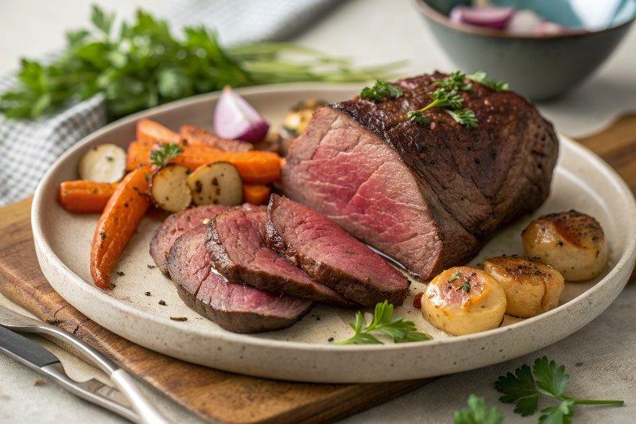

INGREDIENTS  - 1.5 kg higher-welfare topside of beef  - olive oil  - 4 baking potatoes (1 kg total)  - 2 red onions  - 1 bulb of garlic  - 6 large carrots  - 1 small head of cauliflower  - 1 bunch of flat-leaf parsley (30 g)  - extra virgin olive oil  - red wine vinegar  - 350 g ripe mixed-colour tomatoes | PREP  COOK  PLATING

