CLASSIC YELLOW CUPCAKES WITH MILK CHOCOLATE FROSTING  COOK TIME: 22 min  SOURCE:  #sweet #baking #celebration | 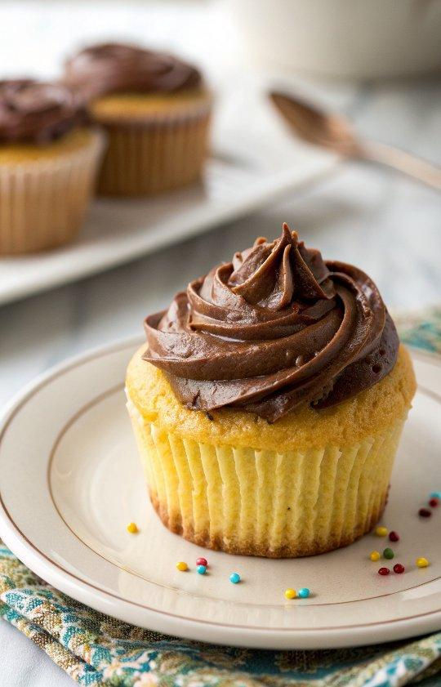

INGREDIENTS  - 1 and 1/2 cups all-purpose flour (spooned & leveled)  - 1 and 1/2 tsp baking powder  - 1/4 tsp salt  - 2 large eggs  - 2/3 cup granulated sugar  - 3/4 cup (12 Tbsp; 170 g) unsalted butter, melted  - 2 tsp pure vanilla extract  - 1/2 cup milk  - 1/2 cup sprinkles  - 1 cup (16 Tbsp; 226 g) unsalted butter, softened to room temperature  - 3 and 1/2 cups confectioners’ sugar  - 1/2 cup unsweetened natural cocoa powder  - 1/2 tsp salt  - 2 tsp pure vanilla extract  - 3 tbsp half-and-half or milk or heavy cream (I used fat free half + half) | PREP  COOK  1. Preheat the oven to 350°F (177°C). Line a 12-count muffin pan with cupcake liners. Set aside.  2. Make the cupcakes  3. Whisk the flour, baking powder, and salt together in a medium bowl. Set aside. In another medium bowl, beat the eggs and sugar with a stand mixer (with paddle attachment) or electric handheld mixer until light and foamy, about 2 minutes. While beating, slowly pour in the butter and then the vanilla. While mixing, add half the dry ingredients, then add all the milk, and follow with the rest of the dry ingredients. Do NOT overmix the batter. Gently fold in 1/2 cup sprinkles.  4. Divide the batter evenly in the prepared cupcake liners. Bake for about 20-25 minutes until a toothpick inserted in the middle comes out clean. Allow cupcakes to cool completely before frosting.  5. Make the frosting  6. Sift 3 cups (720ml) confectioners’ sugar & cocoa powder into a medium bowl. Set aside.  7. On medium speed, cream butter for a few minutes in a stand mixer with the paddle attachment. Turn speed to LOW and slowly pour in the dry ingredients. Be careful so that the dry ingredients do not blow everywhere! Mix until sugar/cocoa are absorbed by the butter.  8. Turn up mixer to medium speed and add the vanilla and salt. Slowly add in the half + half (or milk or cream) and beat for about 2 minutes or until the frosting reaches a desired thickness. Add the last 1/2 cup of confectioners’ sugar if needed to increase frosting thickness (I did not need it).  9. Pipe or spread the frosting onto the cooled cupcakes. Decorate with additional sprinkles, if desired.  PLATING

