VEGAN CHICKPEA "TUNA" SALAD  COOK TIME: 15 min  SOURCE:  #quick #healthy #protein-rich | 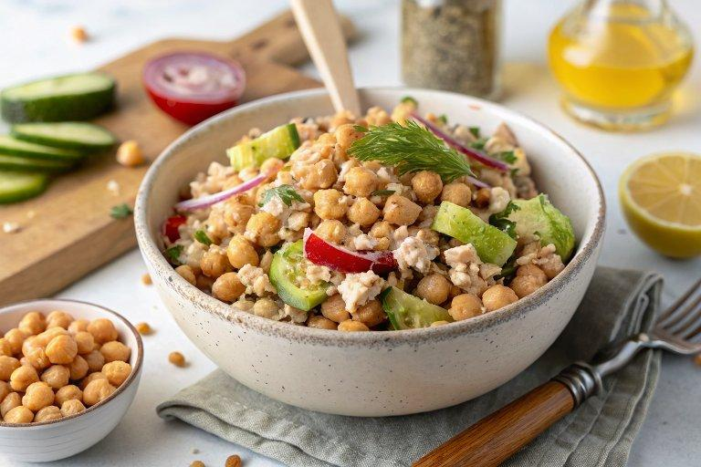

INGREDIENTS  - 1 (15-oz) can chickpeas (drained and rinsed)  - 1/2 small red onion (roughly chopped)  - 1/3 cup celery (chopped)  - 1/4-1/3 cup vegan mayonnaise (or tahini sauce)  - 2 small dill pickles  - 1 1/2 Tbsp lime juice (or lemon juice)  - 2 tsp Dijon mustard  - 1 nori sheet (crumbled into small pieces)  - 1 tsp capers (optional)  - 1/2 tsp dried dill  - Salt and pepper (to taste)  - Bread slices (for serving) | PREP  COOK  1. You can watch the video in the post for visual instructions.First, roughly chop the red onion, celery, and dill pickles, and transfer them to a food processor along with all the remaining ingredients.  2. Pulse the mixture about 8-12 times until it’s well incorporated but still has plenty of texture.  3. OR, if you don’t have a food processor, finely dice the veggies first, transfer the chickpeas to a medium-large bowl and roughly mash them with a fork or potato masher, then add in the remaining ingredients and stir to combine.  4. Finally, taste the vegan tuna salad and adjust any of the flavors (mayo, lemon/lime, mustard, dill, salt & pepper). Enjoy!  PLATING

