EASY VENISON STEW  COOK TIME: 2h 30m  SOURCE:  #comfort-food #hearty #stew | 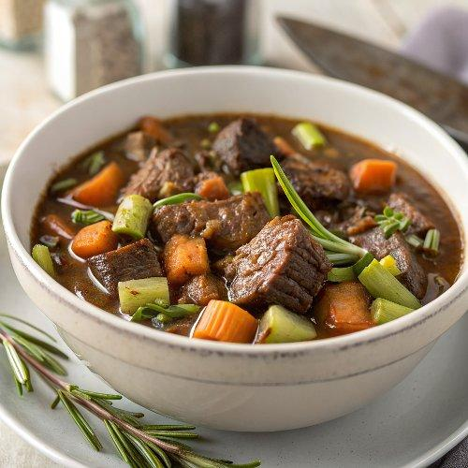

INGREDIENTS  - 800 g diced venison (shoulder or leg works well)  - 2 tbsp vegetable or sunflower oil  - 12 shallots peeled (see tip below)  - 3 medium carrots roughly chopped (no need to peel)  - 2 celery sticks roughly chopped  - 3 tbsp plain flour  - 250ml (1.0 cups) red wine  - 500ml (2.1 cups) beef stock  - 2 tbsp tomato purée  - 2 tsp juniper berries lightly crushed  - 2 bay leaves  - few thyme sprigs  - chopped parsley to serve (optional) | PREP  COOK  1. Season the venison and heat 1 tbsp oil in a large pan over a medium heat. Brown the meat all over (it’s best to do this in batches). Set aside.  2. Drizzle in the remaining oil, then tip in the shallots, carrots and celery and cook for 10-12 mins over a medium-low heat until softened. Stir the venison back in, then sprinkle in the flour. Stir to coat everything, then cook for a couple of minutes before pouring in the wine. Simmer for a few minutes to cook off the alcohol.  3. Pour in the stock to cover, topping up with 100-200ml water, if needed. Add the remaining ingredients and bring to a simmer. Reduce the heat so that it’s just bubbling, then cook for around 2 hrs until the meat falls apart easily. Will keep frozen for up to three months. Defrost fully before reheating. Scatter with the parsley, if using. Serve with rumbledethumps (see recipe below).  PLATING

