GOCHUJANG CHICKEN WINGS  COOK TIME: 1h  SOURCE:  #spicy #grilled #comfort-food | 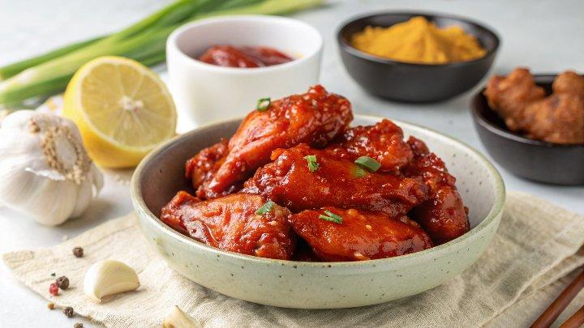

INGREDIENTS  - 1 kg chicken wings  - 3 tbsp baking powder  - 1 tsp garlic granules  - 2 tbsp vegetable oil plus extra for brushing  - 1 tbsp Sichuan peppercorns  - 1-2 garlic cloves crushed  - 10 g fresh ginger grated  - 1 tbsp gochujang  - 2 1/2 tbsp honey  - 1 tbsp soy sauce  - 2 tbsp rice vinegar | PREP  COOK  1. Heat the oven to 220C/200C fan/gas  8. Cut the chicken wings in half at the joints and discard the tips if they are still attached. Using kitchen paper, pat the wings dry, then toss in a bowl with the baking powder, garlic granules, 1 tsp salt and ¼ tsp ground black pepper  2. Set a wire rack over a foil-lined roasting tray. Brush the wire rack with a little vegetable oil to prevent the wings from sticking. Arrange the wings, skin-side up, on the wire rack. Make sure to space them so that the wings do not overlap. Bake for 1 hr, turning the wings over every 20 mins.  3. Crush the peppercorns using a pestle and mortar. Put a large frying pan over a medium heat and toast the crushed peppercorns for 2 mins, then tip into a bowl and set aside.  4. Return the frying pan to the hob with 2 tbsp oil over a medium heat. Add the garlic and ginger and fry for 2 mins until the garlic has softened. Add the gochujang, honey, and soy sauce. Continue to stir for 2 mins until the sauce has thickened slightly. Stir in the crushed peppercorns, rice vinegar and 2 tbsp water or enough to loosen the sauce. Set aside until the wings are cooked.  5. Once the wings are cooked, add the wings to the sauce and toss until coated. Transfer to a large serving platter and serve immediately with plenty of napkins.  PLATING

