EASY ZUCCHINI CAKE  COOK TIME: 48 min  SOURCE:  #quick #comfort-food #baking | 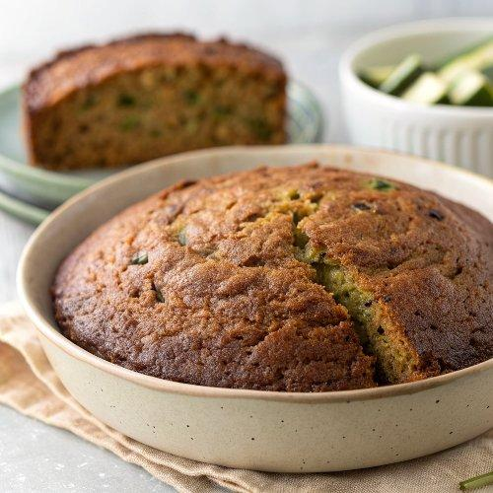

INGREDIENTS  - 2 and 1/2 cups (313 g) all-purpose flour (spooned & leveled)  - 2 tsp baking powder  - 3/4 tsp baking soda  - 1/2 tsp salt  - 2 tsp ground cinnamon  - 1/2 tsp ground nutmeg  - 1 cup (240 ml) vegetable oil  - 1 and 1/4 cups (250 g) packed light or dark brown sugar  - 1/2 cup (100 g) granulated sugar  - 1 cup (240 g) unsweetened applesauce, at room temperature  - 4 large eggs, at room temperature  - 1 tbsp pure vanilla extract  - 1 and 3/4 cups (210 g) shredded zucchini (no need to blot)  - 1/4 cup (4 Tbsp; 56 g) unsalted butter, cut into 4 slices  - 8 oz (226 g) full-fat brick cream cheese, softened to room temperature  - 2 and 1/2 cups (300 g) confectioners’ sugar  - 1 tsp pure vanilla extract  - pinch salt | PREP  COOK  1. Preheat the oven to 350°F (177°C) and grease a 9×13-inch (33cm) baking pan.  2. Make the cake  3. Whisk the flour, baking powder, baking soda, salt, cinnamon, and nutmeg together in a large bowl. Set aside.  4. Whisk the oil, granulated sugar, brown sugar, applesauce, eggs, and vanilla extract together in a medium bowl. Pour the wet ingredients into the dry ingredients and whisk until combined. Fold in the shredded zucchini until combined.  5. Pour and spread batter evenly into the prepared pan. Bake for 45–50 minutes. Baking times vary, so keep an eye on it. Around the 30-minute mark, loosely tent with aluminum foil to prevent over-browning. The cake is done when a toothpick inserted in the center comes out clean.  6. Remove the cake from the oven and set the pan on a wire rack. Allow to cool completely.  7. Brown the butter  8. Set out a medium heatproof bowl because you’ll need it at the end of this step. Place the sliced butter in a light-colored skillet or saucepan. A light-colored interior is crucial for determining when the butter begins to brown. Melt the butter over medium heat and stir or whisk constantly. Once melted, the butter will begin to foam. Continue stirring/whisking, keeping a close eye on it. After about 5–7 minutes, the butter will begin browning and you’ll notice lightly browned specks forming at the bottom of the pan. The butter will have a nutty aroma. The color will gradually deepen, from yellow to golden to golden-brown; once it’s a light caramel-brown color, remove from heat immediately and pour into the bowl, including any brown solids that have formed on the bottom of the pan. Cool for 10 minutes, then transfer to the refrigerator to cool completely and solidify.  9. Make the frosting  1  0. In a large bowl using a handheld or stand mixer fitted with a paddle or whisk attachment, beat the solidified brown butter on high speed until creamy and smooth. Add the cream cheese and beat again until smooth and combined. Scrape down the sides and bottom of the bowl as needed. Add confectioners’ sugar, vanilla, and salt. Beat on low speed for 30 seconds, then switch to high speed and beat for 2 minutes. Spread the frosting on the cooled cake.  1  1. Slice and serve.  1  2. Cover leftover cake tightly and store in the refrigerator for up to 5 days.  PLATING

