BRUSSELS SPROUTS GRATIN  COOK TIME: 45 min  SOURCE:  #comfort-food #casserole #vegetable | 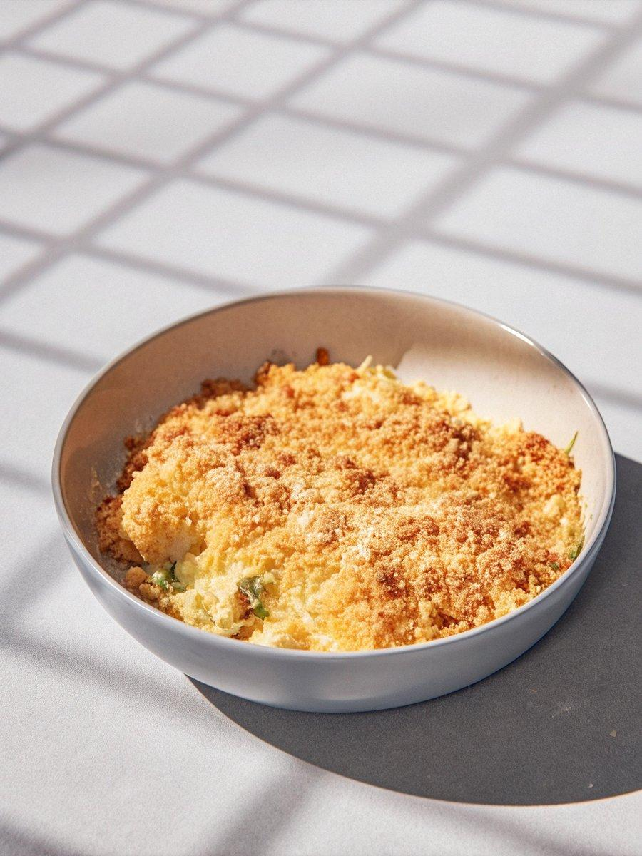

INGREDIENTS  - 2 lb Brussels sprouts, (stem ends trimmed and cut in half through the stem end)  - 3 tbsp unsalted butter, (melted)  - Salt  - Freshly ground black pepper  - 1 cup (240ml) coarse fresh bread crumbs, (from about 3 slices white sandwich bread, crusts removed)  - 1/4 cup finely grated Gruyère  - 1 1/4 cups heavy cream, (at room temperature) | PREP  COOK  1. Heat the oven to 425°F (220°C). Put the Brussels sprouts in a 9 x 13-inch (23 x 33-cm) ceramic or metal baking dish, and toss with 2 tablespoons of the melted butter, ¾ teaspoon salt, and ¼ teaspoon pepper. Spread the sprouts evenly in the dish and roast, tossing once halfway through, until tender and browned in spots, 25 to 30 minutes.  2. While the sprouts roast, place the bread crumbs in a medium bowl. Pour the remaining tablespoon of melted butter over the crumbs and sprinkle with ⅛ teaspoon salt. Mix in the Gruyère. Set aside.  3. When the sprouts are tender and browned, pour the cream evenly over the sprouts and sprinkle with ¼ teaspoon salt. Continue baking until the cream has thickened to a saucy consistency, about 10 minutes. Remove the pan from the oven. Set the oven to broil and position a rack to 6-inch (15cm) below the broiler. Sprinkle on the bread crumb mixture. Broil the gratin until the crust is golden brown, 3 to 5 minutes (keep a close eye on it so it doesn't burn).  PLATING

