SOY SAUCE BUTTER PASTA WITH SHRIMP AND SHIITAKES  COOK TIME: 20 min  SOURCE:  #quick #comfort-food #seafood | 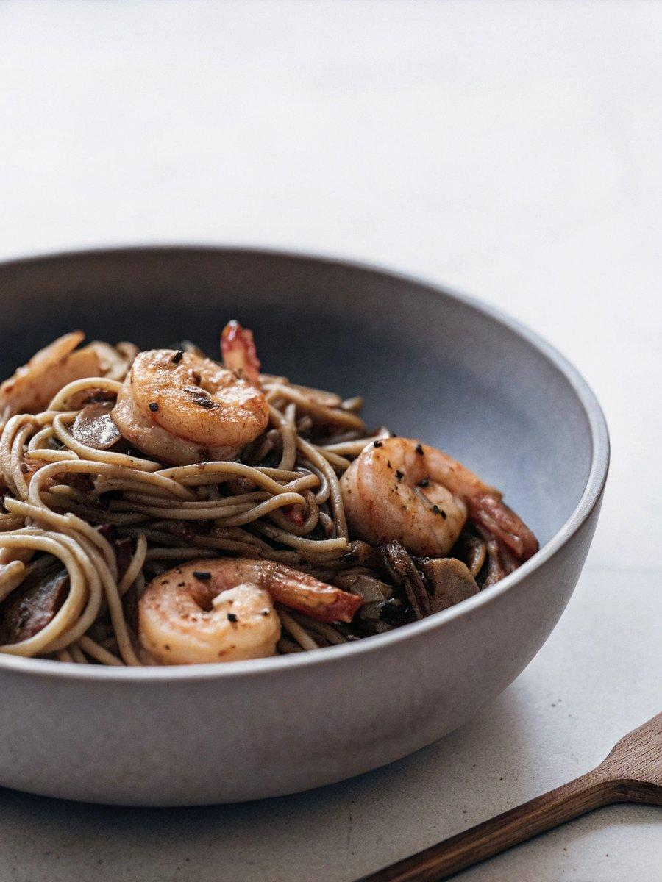

INGREDIENTS  - 10 oz. dried pasta of your choice (about 300 g, we used thin spaghetti)  - olive oil  - 8 oz. shrimp (225 g, peeled, deveined, and thoroughly pat dry)  - 2 cloves garlic (minced)  - 2 shallots (minced)  - 8 oz. shiitake mushrooms (about 10-12 mushrooms/225 g, thinly sliced)  - 1/3 cup white wine  - 3 tbsp soy sauce (salt levels vary across different brands. Try to find a low sodium version)  - 3 tbsp butter  - 1/4 cup parsley (chopped)  - 1/3 cup Parmesan cheese (grated)  - Salt and pepper | PREP  COOK  1. Bring a pot of water to a boil for your pasta. Heat 2 tablespoons olive oil in a large skillet over high heat, until the pan is almost smoking. Sear the shrimp just until opaque and crisp on the outside. Remove from pan and set aside.  2. Reduce heat to medium and add the garlic and shallots. Sautee until beginning to caramelize, about 2 minutes. Add the sliced mushrooms and caramelize, 5-7 minutes. If the pan is looking a little dry, add a bit more olive oil.  3. Boil pasta according to package directions, drain, and reserve a cup of pasta water. Deglaze the mushrooms with white wine and cook for another two minutes, until most of the liquid has evaporated.  4. Add the cooked pasta, soy sauce, and butter to the pan and toss until the butter is melted. Add the shrimp, parsley, and Parmesan, and give everything a final toss. Loosen it up with a bit of your reserved pasta water if needed. Add salt and pepper to taste (remember that soy sauce is quite salty, so you may not need any more salt at all), and serve.  PLATING

