YELLOW SHEET CAKE WITH CHOCOLATE FUDGE FROSTING  COOK TIME: 22 min  SOURCE:  #cake #chocolate #sweet | 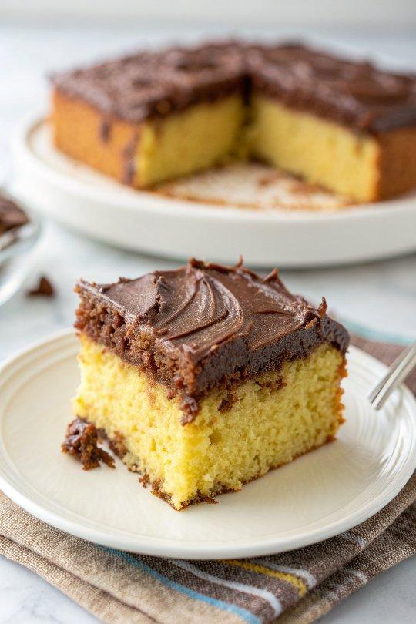

INGREDIENTS  - 2 and 1/4 cups (266 g) cake flour (spooned & leveled)  - 2 and 1/2 tsp baking powder  - 1/4 tsp baking soda  - 1/2 tsp salt  - 1 cup (16 Tbsp; 226 g) unsalted butter, softened to room temperature  - 1 and 1/2 cups (300 g) granulated sugar  - 2 large eggs, at room temperature  - 2 tsp pure vanilla extract  - 1/2 cup (120 g) sour cream, at room temperature*  - 1 cup (240 ml) whole milk, at room temperature*  - 1 cup (16 Tbsp; 226 g) unsalted butter, softened to room temperature  - 4 and 1/2 cups (540 g) confectioners’ sugar  - 3/4 cup (62 g) natural unsweetened or dutch-process cocoa powder  - 1/2 cup (120 ml) whole milk  - 1 tbsp light corn syrup*  - 1 and 1/2 tsp pure vanilla extract  - 1/8 tsp salt  - optional: rainbow sprinkles | PREP  COOK  1. Preheat oven to 350°F (177°C). Generously grease and lightly flour a 12×17-inch (43cm) half sheet pan or a 9×13-inch (33cm) quarter sheet pan. Set aside.  2. Whisk the cake flour, baking powder, baking soda, and salt together in a large bowl. Set aside.  3. Using a handheld or stand mixer fitted with a paddle attachment, beat the butter and sugar together on high speed for 3 full minutes. Scrape down the sides and up the bottom of the bowl with a silicone spatula as needed. Turn the mixer down to medium-high speed and beat in the eggs and vanilla extract until combined. Scrape down the sides and up the bottom of the bowl as needed. Beat in the sour cream.  4. Add 1/2 of the cake flour mixture/dry ingredients and 1/2 of the milk and beat on low speed until combined. Add the remaining dry ingredients and milk and beat on low speed until combined. Do not overmix this batter. The batter will be smooth, velvety, and slightly thick. You may need to whisk it all by hand to make sure there are no lumps at the bottom of the bowl.  5. Spread the cake batter into the prepared pan. Smooth it out into a thin, even layer. For a 12×17-inch (43cm) sheet cake, bake for 20-22 minutes or until the top is lightly browned and a toothpick inserted in the center comes out clean. For a 9×13-inch (33cm) sheet cake, bake for 36-40 minutes or until the top is lightly browned and a toothpick inserted in the center comes out clean. With either size, make sure you rotate the cake pan once or twice during bake time.  6. Remove from the oven and allow the cake to cool in the pan placed on a wire rack. As the cake cools, make the frosting.  7. Make the frosting  8. Using a handheld or stand mixer fitted with a paddle attachment, beat the butter on high speed until pale, smooth, and creamy, about 2 minutes. Using a fine mesh strainer, sift the confectioners’ sugar and cocoa together. Add the sugar/cocoa mixture to the butter, then beat on low speed for 20 seconds. Stop the mixer, then add the milk, corn syrup, vanilla, and salt. Beat on medium-high speed for 2 minutes. If the frosting is too thick, beat in an extra splash of milk.  9. Frost cooled cake and top with sprinkles. Slice and serve. Cover leftovers tightly and store in the refrigerator for up to 5 days.  PLATING

