SUNNY SIDE UP EGGS  COOK TIME: 2 min  SOURCE:  #quick #comfort-food #breakfast | 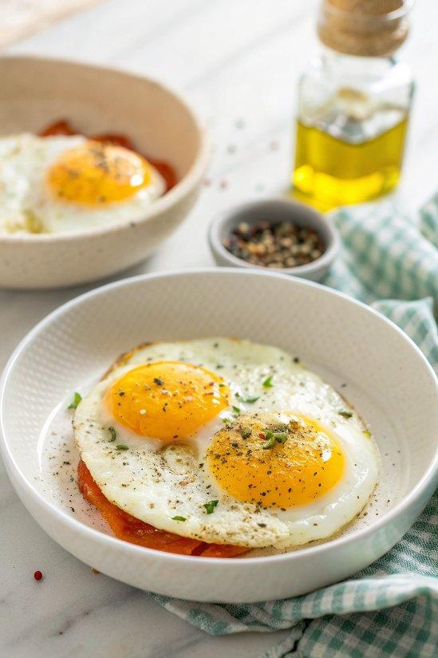

INGREDIENTS  - 2 to 3 eggs  - Extra-virgin olive oil (for the pan)  - Sea salt and freshly ground black pepper | PREP  COOK  1. Crack each egg into a ramekin or small bowl.  2. Brush a nonstick skillet with olive oil and heat over low heat. Pour in the eggs, cover with a clear glass lid, and continue to cook over low heat for about 2 minutes, or until the whites are set.  3. Season with salt and pepper and serve hot.  PLATING

